James Kesner

용인시 수지구 풍덕천동 1104 주공@ 901/501
010-8932-0942
jamesrkesner@hotmail.com

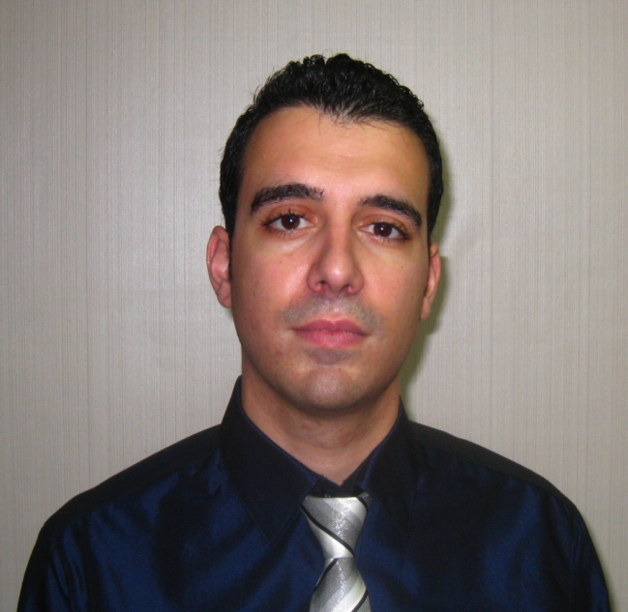
Personal

Birth: Canada, 09-June-1983
Citizenship: Canadian
Mother Tongue: English
Visa and Marital Status: Married with an F-2 (spousal visa)

Education

2006: TESOL/TESL Certification, Oxford Seminars, Waterloo, Ontario, Canada

2002-2006: Bachelor of Arts – Honors English Literature, with a Minor in History,
University of Waterloo, Waterloo, Ontario, Canada

Work Experience

ESL Teacher Hongcheon Middle School Sept. 2008 – Sept. 2010
- Created lesson plans following the middle school curriculum for levels ranging from beginner to advanced
- Taught extra-curriculum conversation classes
- Taught winter and summer vacation classes
- Assisted in the editing of the mid-term and final examinations

ESL Tutor Jan. 2008 – June 2008
- Tutored ESL Korean university students, both privately and as an employee of Woori Education Group in Toronto, Ontario, Canada
- Assisted students with conversation, pronunciation, grammar, writing and vocabulary studies

Substitute ESL Teacher Woori Education Group Feb, 2008 – March 2008
- Prepared and taught lesson plans and topics for conversation-based classes
- Directed debates on a series of topics with ESL Korean university and adult students

ESL Teacher Reading Town, Jukjeon Campus Aug. 2006 – Aug. 2007
- Travelled to The Republic of Korea to pursue a teaching job
- Taught classes which ranged from elementary to high school
- Created and organized lesson plans for levels ranging from beginner to advanced
- Held dialogues with students’ parents
- Participated in weekly meetings

Skills & Experience

- I have experience in teamwork, whether it is part of a staff in an English school, in a factory, on a construction site, or in customer service.
- I excel in written and oral communication and possess the necessary skills of creativity and patience when preparing and teaching ESL lessons.
- I’ve traveled throughout much of Eastern Canada, the United States and the Republic of Korea, as well as countries in Western Europe and South-East Asia.

References & Transcripts

Available upon request:

University Degree Diploma
TESL Certificate
Letters of Recommendation

