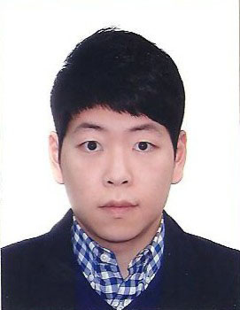
ERIC (JINHYUN) KIM
010-7654-2277
Jinhyun829@gmail.com
1986/08/29

I lived in Seoul when I was a child. So, I am familiar with Korean culture and I know what kind of learning environments Korean students are exposed to. Later, I have immigrated to Canada with my family and eventually acquired Canadian citizenship. This job as an English teacher is an amazing opportunity for me, and teaching English to the young generations of Korea is both a privilege and honor for me.

I want to play a supportive role in the development of ESL program in Korea.

One of my strengths is that I can speak both languages of Korean and English fluently. Nowadays, the young students, often referred to as the digital generation, no longer want to adhere to traditional and outdated modes of English teaching. What they want is a more creative and practical use of English rather than pure regurgitation of sentences and problem sets. With this in mind, I try to pursue a creative and an interactive teaching method. For instance, I will form a more interactive classroom so that students are able to gain learning experiences not just from a one-way lecture method, but also from other students through the use of discussion and various activities. This way of teaching, in my opinion, will enhance overall learning experience and also provide social and psychological benefits to students (e.g. students getting to know each other better through discussion). I will constantly look for and develop teaching methods to guide students in their educational journey. My background in arts and designs will help me in this endeavour by giving me ways of creative thinking and imagination.

Along with creating a more stimulating and interactive environment, I also place a tremendous value and importance on a teacher’s relationship with a student. I consider myself to be a caring and considerate person. These personal qualities will help me build warm rapport with students.
I am really looking forward to working in this job and thank you.

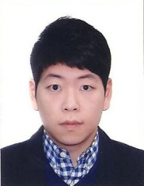
Jinhyun Kim
17 Laredo Crt.
North York Toronto ON. Canada
M2M 4H8
010-7654-2277
jinhyun829@gmail.com

Objective:
Seeking the position of an English Teacher in an organization that will enhance my horizon of knowledge and give me the chance to prove myself as the best candidate in the organization

Summary of Skills:
- Profound knowledge of English language and ability to teach the language for all sorts of students i.e. for those who have English as their first language and those who have not
- Excellent communication and written skills as well as ability to explain the text
- Ability to teach English in different ways or methods i.e. Role play, language games, and dialogue methods
- Highly skilled in using the different course books and material for teaching English as well as having a great passion and love for English language
- Ability to use audio-visual aids for teaching English effectively and creativeness in teaching process
- Ability to plan, collect material, and deliver the lessons in the class
- Capacity to arrange the competitions and assess the performance of the students
- Ability to inspire the students for desired effects in the language teaching task

Education & Awards:
Environmental Design Program (September 2004 – June 2008)
- Ontario College of Art and Designs, Toronto, On
Art History B.A (September 2010 – present)
- York University, Toronto, On
Piano teaching license (April2000 - June2004)
- Royal Conservatory of Music, Toronto, On

Work Experiences:
Customer Service Specialist, Korean air – Toronto Pearson Airport
(March 2008 – June 2010)
- Handling passenger with excellent services (Check-in, VIP services, etc.)
- Able to manage or access ‘BABEL’ (airport Check-in program)
- Manage every flight’s Arrival or Departure with assisting passengers
Assistant Manager/Waiter, Sunny Sushi – Toronto (July 2005 – April 2006)
- Trained new employees / managing payrolls for all employees
- Organized meetings for employees to serve customer improved behavior
Host, Shiki Sushi – Richimond Hill (December 2004 – June 2005)
- Made clean space and high picked services to satisfy customers
- Provide friendly and excellent service to customers

Volunteer Experiences:
Korean Art Students Associations, KASA (Sept 2007 – Present)
- Appointed as a President for 2 years
- Supervising overall group activities; art exhibitions, study groups, and etc
- Organized all the meetings with executives in group
Korean Cultural Event: Comedy Show (June 2005)
- Sold tickets to audiences
- Promoted and advertised the event
Mil-Al Presbyterian Church: Vacation Bible study (July 1999-August 2001)
- Planned and organized meals and activities
- Managed and controlled all financial situations regarding craft activities.

