Curriculum Vitae
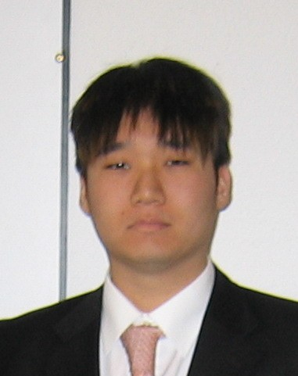

Mr John EunJoon KIM

Guro 3-dong 116 dong apt. #303
Samsung Remian Apartment
E-mail: joonpride@hotmail.com
Telephone: 0082 2 830 0224
Cellphone : 0082 10 7765 5383

3rd of May 1983, American, Single

Objective

To gain experience, in service duties while meeting new people all over the world, and learning different languages.

Educational Background

IHTTI, school of hotel management, Neuchatel, Switzerland 8/04-2/06
HO (hospitality operation)
HM (higher diploma) 2/07-8/07
COC, (college of the canyons), Valencia, California, U.S.A 6/03-5/04
1½ years of college experience
Major: computer engineering/undecided
Hart High School, Newhall, California, U.S.A 6/01-6/03

2 years of High school experience with a graduate diploma
ICS (international Christian school), Youido, Seoul, Korea 6/98-4/01
2 years of High school experience

Professional Experience Neuchâtel, Switzerland

Worked at two fast food restaurants in California
-Arbys (a sandwich store/working in the kitchen, register machine behind the desk, and kitchen)
-Panda Express (Chinese fast food restaurant/behind the counter services, cleaning the kitchen and store)
-Sushi Ai (Japanese Sushi restaurant/behind the counter service as a host and waiter)
-Koreahof (a Korean restaurant/hostel service/housekeeping/kitchen)
-Lotte hotel (a 5-star hotel in Seoul, Korea)
-Hou Kei (a Chinese restaurant in Biel, Switzerland worked in service and kitchen)

Language Skills

English: Fluent
Korean: Fluent
French: Beginner

Computer Skills
Microsoft Word, Power point, Internet

Interests:
Computers, Internet, travelling, meeting new people, learning new languages, and socializing

