
Teacher Profile
Full Name  Joel Kenneth O’Donnell |  | 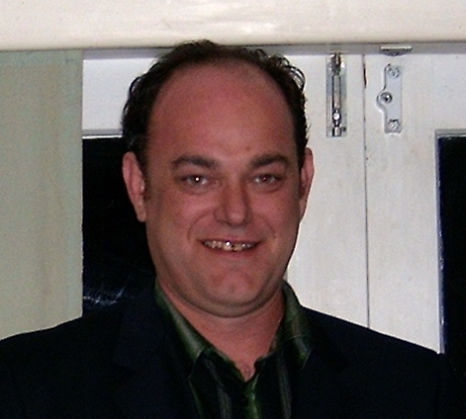  Recent Photo
Age  35 | Gender  Male
Nationality:
New Zealander

Marital Status:
Single
Health

Good
Qualifications.

Bachelor of Business Studies (Massey University, Auckland, New Zealand)
ESL Certified (NZIE, Auckland, New Zealand)
Personal Statement /Comments about reason for seeking work in Korea.

I would love to work in Korea because I love the culture and would love to learn more about it. I also love teaching and think this would be the perfect chance to combine my passions. I love to travel and explore and think living and teaching in Korea would be a great experience for myself, my employer and my students.
Work Experience:

2004-2008
Tutor: During my time at Massey University I also tutored many foreign students in English.

2000-2003
Sales Manager: Abel Tasman Sea Shuttle. Responsible for all sales and marketing and training of sales staff.

1998-1999
Team Leader: Goodwill Marketing. Responsible for all sales and training new staff.
Ph: +64 9 4806989 Home
+64 22 621 3577 Mobile
e-mail: joelodonnell@yahoo.com

