JEFF L. RITCHIE
1727-4 3층 중산동 일산동구 고양시 경기도
jeff_ritchie@hotmail.com
010-9885-2343
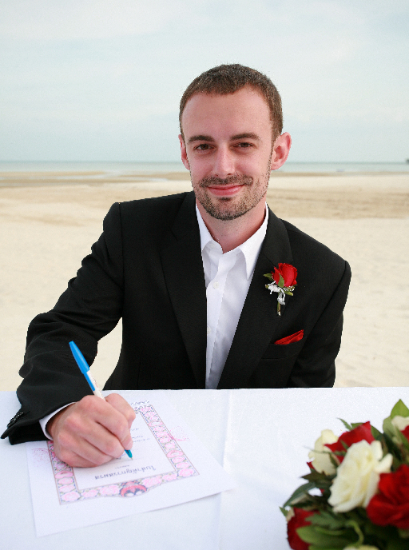

Objective To further my teaching experience from a Canadian perspective in South Korea.
.

Skills
- Interpersonal
- Trustworthy and loyal
- Verbal and written communication
- Hard-working and punctual
- Work well under stress

Education Certificate in Human Resource Management, Saint Mary’s University
Halifax, Nova Scotia, 2005

Bachelor of Arts Degree, Saint Mary’s University
Halifax, Nova Scotia, 2003

Computer Service Technician Certificate, CompuCollege
Halifax, Nova Scotia, 2000

Experience

Afterschool Teacher, Seoshin Elementary School
06/12 to 06/13, Sinsa-dong, Eunpyeong-gu, Seoul, South Korea
- Teach 4 afternoon classes of multiple levels
- Co-developed the curriculum of all classes

Afterschool Teacher, Changlim Elementary School
04/11 to 03/12, Ssangmun-dong, Dobong-gu, Seoul, South Korea
- Taught 5 afternoon classes of multiple levels
- Co-developed the curriculum of all classes

ESL Teacher, LCI KidsClub
10/09 to 11/10, Ssangmun-dong, Dobong-gu, Seoul, South Korea
- Taught a total of 4 afternoon classes, longest class being 3 hours long
- Taught 12 kindergarten students on a daily basis
- In charge of the class development and speed

ESL Teacher, Ewha W Language School
09/08 to 09/09, Sangam-dong, Mapo-gu, Seoul, South Korea
- Taught a total of 16 different classes to over 100 students
- Developed special classes for intensive periods
- The only foreign teacher in the school

ESL Teacher, Brighten English School
02/07 to 10/07, Chungdam-dong, Gangnam-gu, Seoul, South Korea
- Taught a total of 6 classes and 52 students
- Private tutoring for University students
- Aided in the Development of school curriculum

Activities And
Interests
- Traveled South East Asia extensively
- Photography
- Learning new languages and cultures
- Saint Mary’s University Commerce Society
- Second basemen of Colchester County Cardinals Midget AA Baseball team 1998, 1999
- Played competitive soccer for eight years, hockey for 5 years
- Coached and refereed Elementary basketball in 1998 and 1999

Additional work experience and letters of reference are available upon request

