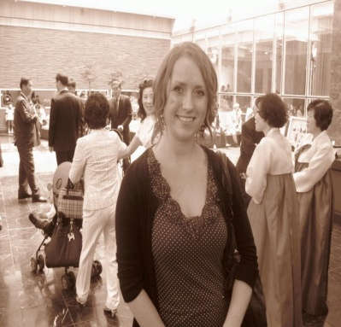
Heather Mary Lennox
British 1/2/1983 littlemisstron@yahoo.co.uk 010 3781 7655

Objective: To find a job as an ESL teacher in Seoul

Education
- 2001-2005 2007
MAHns English and International Relations 120 hour Trinity Cambridge TEFL Certificate
University of Aberdeen, Scotland Prague Schools, Prague

Work Experience
- 2006-2007 2007-2009
ESL Teacher, ages 3-14 Head ESL Teacher, ages 7-adult
TOP English Academy Bluebell English Academy
Gunsan, South Korea Dongtan, South Korea

- 2009-2011 2012-2012
ESL Teacher, ages 7-13 ESL Teacher, ages 3-14
KTW English Academy Easy English Academy
Dongtan, South Korea Anyang, South Korea

I am a friendly, organized individual who is passionate about teaching English and a great team player.

References on request

