Genevieve M. Tecson
Yongin City Suji Gu, Pongdeokchon 1 dong Tongbu Apartment 103-602
Tel: 010-4159-3294 E-mail: sky_bae@yahoo.com
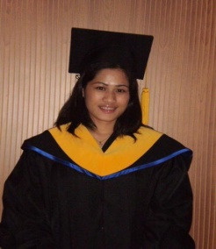
OBJECTIVE:
Students learn different learning style in my teaching on English as second language.
Students will be learned not only in the book of knowledge but also in the life knowledge.
SPECIAL SKILL: Good in both written and oral communication, highly develop in personal relations.
EDUCATION
July 03, 2009 Winglish Tesol & Biz Education Center University Of California, Riverside University Extension.
Yoochang Bld 10th floor 1305-7, Seocho-dong, Seocho gu,
Seoul, korea
Certified TESOL Certificate

March 25, 2002 Bachelor of Science Information Technology. (IT)
Acts College of Technology
Davao City Philippines

EMPLOYMENT HISTORY

JUNE 15, 2002 – DECEMBER 2002 ASSISTANT SCHOOL TEACHER
AGAPE KINDERGARTEN SCHOOL
BANSALAN, DAVAO DEL SUR PHILIPPINEs
AUGUST 2003 –AUGUST 2006 STORE SUPERVISOR – BOYET FAJARDO ROBISONS PLACE IMUS CAVITE PHILIPPINES
OCTOBER 2006 – OCTOBER 2007 JARMAN SHOES CORPORATION
SHOEMART BACOOR CAVITE PHILIPPINES
LANGUAGES
English , Tagalog and Korean.
PERSONALA DATA:

Provincial Address :Davao City
City Address :Davao City
Date of Birth :June 04, 1983
Age :26 years old
Nationality :Filipino
Civil Status :Married
Religion :Roman Catholic

