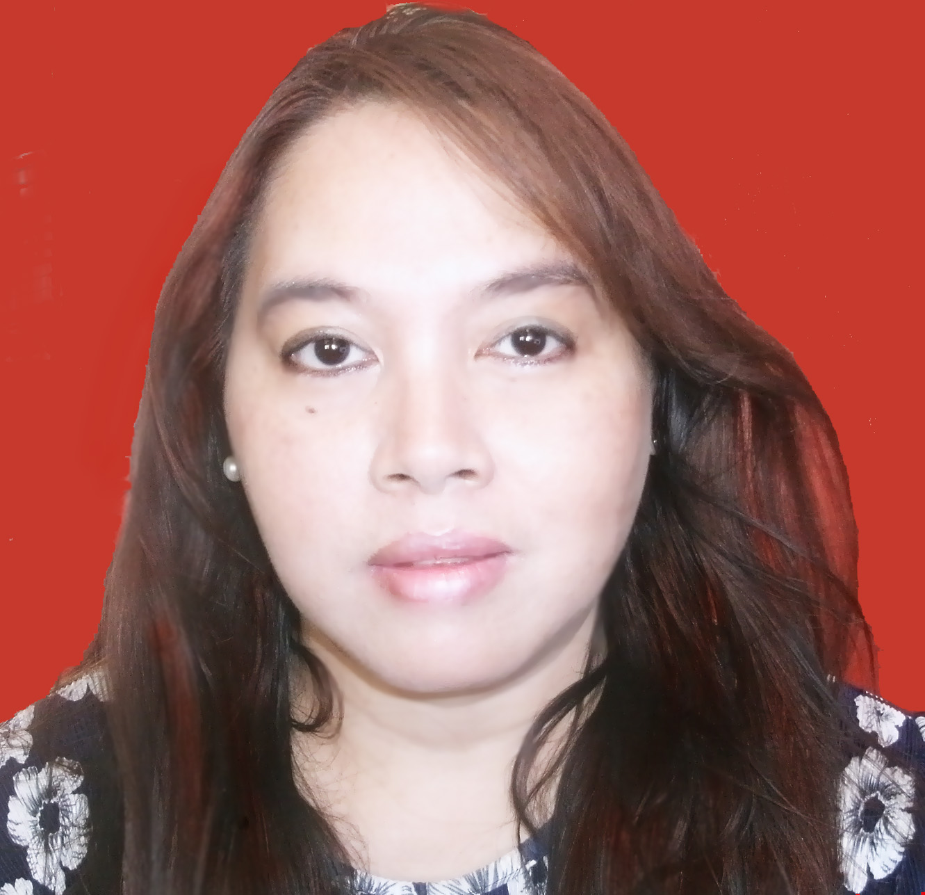

Maria Theresa L. Reyes
25 Panamitan, Kawit, Cavite
Mobile No. +639062570078
thessr2003@gmail.com

Career Objectives:
I would like to apply for the teaching position offered by your company to work with school aged children and adults. If I can teach children at a young age, they will not have problems when they get older especially when dealing with the changing world, where English is the global language. I can also teach Koreans who can understand English but would like to speak with an American accent.

Personal Data
Age: 44
Height: 5’ 3.5”
Weight: 180 lbs
Birthday: April 16, 1968
Bith Place: Cavite City
Sex: Female
Civil Status: Married
Religion: Catholic

Educational Attaintment:

College: Pamantasan ng Lungsod ng Maynila 1984-1988

Course: Bachelor of Science in Business Administration
Major in Acounting

Certificate in Early Childhood Education August 2005

Working Experience

- Home Tutorials English teacher June 2002 to present

- BPI Checking Account/Saving Account June 19, 1992 to April 2002 bookkeeper

Other skills: Can Speak English with or without an American accent
can use Microsoft Word
can make slide shows using Microsoft Power Point
can use Photoshop CS3
already have the experience of dealing with toddlers and teen-agers and adult
English learners

Interests: I love to watch Ellen de Generes’ Show
I love all the CSI shows
loves to cook and bake
loves to watch Korean dramas
last one I have recently watched is Faith: The Great Doctor
with Lee Min Ho in the lead as Woodalchi Daejang Choi Hyung
and currently watching I Miss You with Yoon Eun Hye

COVER LETTER:

Dear Sir,
I'm from the Philippines.
I Graduated with a degree in Business Management.
I am well versed in English grammar and can speak English with or without an American accent.
I used to work for a major bank here in the Philippines for 12 years.
I have been a private tutor to neighborhood kids since 2002. That is how I support myself and my two kids, who are now teenagers.
I would like to be a part of your school program in Seoul, Korea and I promise to be a credit to your faculty.

Two years ago, a tragic incident in our lives left me the sole provider for
myself and two children. I would like to make some positive changes in my life
while helping others. This opportunity of working in Korea will be the most
exciting experience I have had in a long time.

I am looking forward to working with you.

Sincerely,

Thess Reyes

