Strassejunge1982@yahoo.com
Phone: 239-240-0909
Fort Myers FL. USA
Theron Matthew Brown
Communications BA

Qualifications

Teaching:
- World Class Adult Hagwon (12/09- 11/10)
- Sam’s English Academy academy (12/08- 4/10)
- 1 year Wonderland Hagwon School (8/07- 9/08)
- Best Friend’s Tutoring (3/09-11/10)
- Preparing lesson plans & creating own text books
- Preparing students for TESOL examinations
- Taught all ages from 6 to Adult

Professional/Clerical work:
- 3 years at James P. Adams Library at Rhode Island College
- Monitor internet network
- Catalogue new books, microfilm, microfiche using MS Excel, and MS Word
- Excellent public service, customer service relations
- Handle telephone call volume

Communications:
- Operation of television studio equipment
- 2 years of imovie and final cut pro
- Operation of sound board in control room
- Operation of digital video and sound equipment
- Repairing and maintaining of electronic equipment
- Knowledge of communication theories and concepts
- .
Customer Service, Sales, Marketing and Hospitality
- 5 years Bartending and waiting experience in bars, night clubs, restaurants, banquet halls, and private events in Rhode Island as long as Seoul, South Korea.
- 1 year Superba Tie sales man in Providence place mall
- Red Peg marketing and Gorilla marketing. Promoting local and national clients.
- 1 year driver/counter person at Pep Boys Pawtucket R.I
(All work was part-time and/or seasonal)

Education
Bachelor’s In Communications

Rhode Island College

- Successfully completed 121 credits May,19 2007
- Bachelor Degree in Communications
- 17 credited hours in German Language

Military:
- 1 year U.S. Air force Reserves PFC
- 2 years 6months ARMY R.O.T.C. training at Providence College University
- 12 Military science credits were added to my college transcript for successful completion of ARMY R.O.T.C. courses.
Work Experience

December 2009 – November 2010
World Class Adult Hagwon
http://www.world-class.kr/
English teacher: A business motivated company that landed on hard times. Students were the best aspect of this English academy. They proclaimed they had texts and teachings prepared but their curriculum was short to nothing until now. Preparing new and innovative conversation and grammar lesson plans was imperative at this school without any preparation time. Creating of original lessons on modern topics with exercises and speaking activities for adult students was new, challenging, but fun. Most students ranged from college to professional business men. Teaching each particular student with their specific individual needs in English for professional or schooling purposes proved to be challenging yet exciting.. I came up with my own unique lessons using Breaking News English lessons that involve teaching about new hot topic issues. I balanced school curriculum and my own curriculum excellently.

- December 2008- April 2010

Sam Academy

English Teacher: Preparing lessons for elementary school to middle school students. A more advance school than my previous hagwon. Most students have had previous teaching or lived over seas and speak extremely well. Emphasis on reading, vocabulary and conversation skills is essential for their learning. Also taught a TOEIC class on Saturday.

- December 2008- November 2009
(현산초) HYUNSAN Public Elementary School
http://www.hyunsan.es.kr/
English Teacher: Preparing Lesson plans, creation of texts, teaching after school programs, drama club, and teaching English camps during school vacations. Taught Government English curriculum alongside of my own texts and teaching methods developed while teaching at Wonderland School in 부천(Bucheon). Class size was more than quadruple in Hyun-San than in Wonderland. Class size ranged from 35 to 50 students per class. This school was my least favorite position. I was discriminated against and had my personal life invaded, belongings stolen from Academic supervisors, and never have I been treated like that anywhere in Korea.

August 2007 – September 2008
Wonderland Sosa Hagwon
http://www.wlsosa.co.kr
English teacher: Prepare lessons, improving student’s speech, morning assemblies, monitoring field trips. Wonderland is an excellent English academy chain that offers students the chance to learn English from ages 5 & up. A majority of the students achieve fluency before 7th grade depending on their length of study. Prepare older students for TESOL English examinations. This was my first and best experience in Korea. My director, manager, and co-workers provided a pleasant and fun atmosphere. I wish I stayed longer but I really didn’t want to continue teaching morning kindergarten which was required.
- Dec 2003 - July 2006
  - James P. Adams Library
600 Mt Pleasant Ave. Providence, R.I. 02908
Microform assistant/ supervisor: monitor & Maintain internet network, printer network, copy machines, microform, and microfiche machines. Fulfilled requested ILL’s (Inter library loans) by telephone, fax, or e-mail. Cataloging, updating new and old materials and periodicals using Microsoft Excel. Opening and closing of Microforms office, instructing classes on how to use the microforms room and public service.

REFERENCES:

KOREA US
승교진 : 017-259-7765 Tisch Brennan 401-456-8125
C.P.A. Tutored business English. Reference Librarian and supervisor
For microforms.

고승원 /Kevin: 010-2697-6150 (82 10 2697-6510) Igor Konovalenko 401-744-3115
Manager of Wonderland hagwon in bucheon sosa. Pep Boys Manager retired army.

Anna: 010-3131-1581 (82 10 3131 1581)
Owner of Sam English academy were I did Toeic, and
toefl preparations and taught middle school students.

승기창 : 010-9214-3911 (82 10 9214-3911)
Lieutenant fireman formally of 일산소방소.I tutored him in preparation for a Texas A&M fire marshal academy.

I’m familiar with Many co-workers and friends all throughout 경기도 (Gyong-Gi-Do) who are co-workers, students, professionals and friends who’ve I tutored, created lesson plans with, prepared for foreign travel, and creation of original text books.

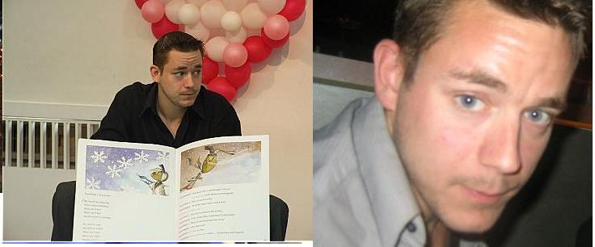

I take great personal pride in all the work I’ve done in Korea and personally feel very privileged to have met everyone I have and to have gone through all the experiences I’ve had in Korea.

