____________________________________________________________________

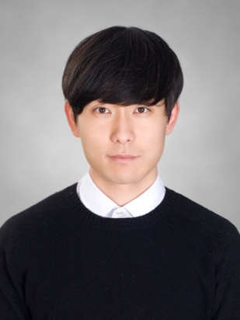
Resume:
Josh Noh
____________________________________________________________________

Personal Details Name Sungwoo Noh(Josh)
Date of Birth 1985 / 04 /23
Nationality New Zealand
Address 32-23, Dapsimni 2-dong,
Dongdaemun-gu, Seoul, Korea
Visa Type F4
____________________________________________________________________

Education History 2003 Massey High School (Graduated)

2005 AMES I.T. Academy
Certificate in Computer Graphics

2008 Whitecliffe College of Art and Design.
Major in Fine Art (Bachelor of Fine Art)
(Graduated)
____________________________________________________________________

Work History

2009 Jan- 2010 Sep. Cool Mobile : Mobile Phone Retailer and wholesaler Auckland. NewZealand.

- In charge of sales assistants and stock management.
- Working as a sales manager in a team environment, communicating with co-workers and provide quality services for customers.

2011 Sep - Present Langcon English Seodaemun-gu, Seoul.

- Working as a Native English Teacher. All lessons were conducted in English.
- Taught English curriculum to the both junior and senior grade elementary students.

____________________________________________________________________
____________________________________________________________________

Personal statement

I have worked in a private English institute for 3years. The Langcon English school's curriculum is conversation based. Although it is not a part of the curriculum, I pay extra attention to students speaking in my classes. Being naturally verbal and extroverted, I enjoy classes where speaking is an important component. Since I speak Korean, I have a clear understanding when students encounter with difficult challenges in the lessons.
In my classroom, I try to create balance between fun and work. I believe that children are the most comfortable in the environment where fun and creativity exist within clearly boundaries. The location of those boundaries depends on the students' unique challenges and personalities. In an ideal classroom environment, students would be able to learn by seeing, doing, and hearing. Since we can easily remember what is relevant to us, I try to use examples from everyday life to help create a permanent memory in the students' minds.

____________________________________________________________________

Reason for applying to Kindergarten/Pre school academy

After working in my current job for more than three years, I wanted to have teaching experience in early childhood education. I love to interact with children, and I can do my best in both small or big class environment. I am looking to work where creativity is incorporated more into the curriculum. I found that, Kindergarten/early childhood education academy has more creative classes compare to where academy based on "text book". I think it would be a good fit for me. Having been very involved in the arts growing up, and I have lots of art making experience through my college life.
I know how much the skills learned from the arts could help young children in all areas of life. I hope that I can pursue my passion for teaching at your institution.
____________________________________________________________________

Referees

Henry Symonds Hye-Sun Lee (Jenny)

Dean of Instruction and Undergraduate Studies Campus Director
Whitecliffe College of Arts and Design Langcon English
24 Balfour Road, Parnell 469, Hongje 1-dong, Seodaemun-gu
Auckland, New Zealand. Seoul, Korea
+64 9 309 5970 +82 2 730 3800
HENRYS@WHITECLFFE.AC.NZ 010 7363 1680
www.whitecliffe.ac.nz jesus-2hs@hanmail.net
www.langcon.co.kr

____________________________________________________________________

