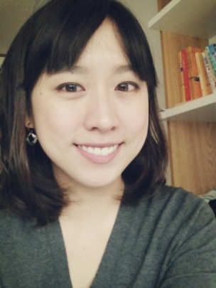 Shirley Lin
Profile:
I am a friendly teacher who easily connects and builds relationships with my students. I strive to create a comfortable learning environment that promotes confidence in learning. I believe in positive reinforcement and having respect in the classroom. I am a respectful, dependable, and detail oriented team player.
Experience:
Mokhyeon Elementary After School English Program Seoul, Korea 2012- 2013
- Native English Teacher for approximately 60 students in grades 1-6
Private English Tutor Taipei, Taiwan 2011- 2012
- One on One tutor for 2 adults
- Worked on conversation, discussion, and reading
- Focused on current event articles and discussions
Happy Top Children’s English School Taipei, Taiwan 2010- 2011
- One on One tutor for elementary student
- Developed lessons based on reading, writing, and speaking
Private English Tutor Taipei, Taiwan 2010- 2011
- One on One English Tutor for elementary school student
- Developed lesson plans and worked with student on reading, writing, and spelling

Education:
University of Nebraska Bachelor’s of Science in Business (Accounting) Honor Roll GPA: 3. 8 ICAL 100 Hour TEFL Course

Skills:
- Ability to read and write basic Hangul
- Proficient in Microsoft Office
- Ability to integrate technology into the classrom

