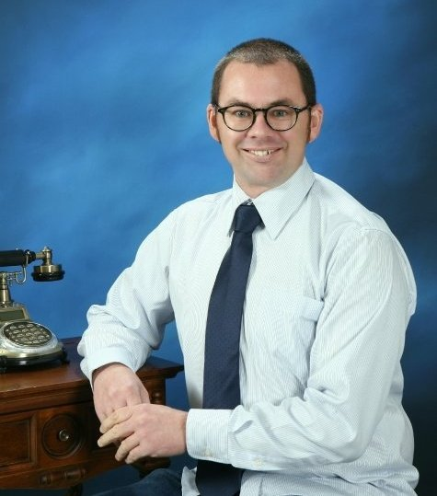
Scott William Marris
28 van Diemen Street
Nelson 7010
NEW ZEALAND

027
scott.marris@yahoo.co.nz

PHILOSOPHY OF TEACHING
Students achieve best when learning experiences are constructive and enjoyable. Having an awareness of differences that students bring to class, along with prior knowledge they have and are able to share is another aspect that is essential. Furthermore, being dedicated, committed and flexible in how I teach is important so all students can be catered to in their individual learning experiences.

EDUCATION AND QUALIFICATIONS
University of Otago 2001-2003 Bachelor of Teaching (Primary)
Kiwisport Certificate
Lotto Swimsafe Course
Catechetical Studies Course
Sign Language Course

Nelson College 2000 University Entrance
Higher School Certificate

Nelson Polytechnic 1990-1993 ESOL Home Tutor Certificate
Further Japanese Course
Basic Business Studies Course
Tourism and Hospitality Services Course

Nelson College 1984-1988 Sixth Form Certificate

RELEVANT EXPERIENCE
I first became interested in teaching when I tutored English to Japanese students while living in the Kansai region of Japan. I returned to New Zealand and chose to pursue a career in teaching beginning with study at the University of Otago. While studying for a Bachelor of Teaching (Primary) degree, I gained insight to critical literacy, issues related to New Zealand’s Treaty of Waitangi, reflective teaching practices and integration techniques. Life experience helped immensely with my studies and placement in schools where I tailored my teaching to include students of varying abilities. Since graduating, I have been responsible for a composite class of Year 7 and 8 students in a full-primary school in Auckland, New Zealand, as well as continuing second language teaching for Nova Group, both in branches and at local elementary schools in Tochigi, Japan. I have also taught for 13 months at a hagwon catering to kindergarten-aged children and up to 12-year-olds in Bucheon, South Korea.

WORK EXPERIENCE
Teacher – Brighton Junior English School, South Korea 2008-2009
Teaching English to children from kindergarten age up to upper elementary school age.

Instructor and Assistant Language Teacher – Nova Group, Japan 2005-2007
English as a second language teaching to adults and children.

Primary School Teacher – St. Joseph’s School, Pukekohe, New Zealand 2004-2005
Responsible for a composite Year 7 and 8 class.

Note Taker – Disabilities Office, University of Otago 2001-2003
Responsible for clear, concise notes for students.

School Bus Driver – Nelson Christian Academy 1998-2005
Safely commuting students to and from school.

Working Holiday – Devon, England 1995-1997
Hotel waiting and dining room supervisor.

Working Holiday – Kansai, Japan 1991 and 1994
English language tut’ring, catering, drain-laying and concreting.

SPORTS AND INTERESTS
Gymnastics – Representing Nelson and Wellington 1978-1985. National champion 1981.

Swimming – Lotto Swimsafe course enabling coaching.

Language and Culture – Overseas experience exploring culture and language has led to an ability to speak Japanese at a competent level. Also studied German at secondary school. Attained ‘A’ passes in both German and te reo Maori at university.

Information Technology – Self-taught in computer literacy. Often called on to assist others. Developed own website to advertise photography services.

Photography – Chief photographer at weddings. An ‘A’ pass in Year 13 as an adult student at Nelson College in 2000.

COMMUNITY INVOLVEMENT
Salvation Army 2003 – Voluntary support for an after school programme set up to assist children with homework. Assisting in implementation of Kidzone (Sunday School) Programme for 3 to 7-year-olds.

Nelson Sister Cities Committee 1992 – Supporting the link between Nelson and Miyazu Cities.

FUTURE GOALS
Become fluent in te reo Maori as a personal goal but also to better engage tangata whenua in the New Zealand learning environment. Also attain fluency in Japanese language and undertake study of Spanish.

Begin learning guitar to bring a greater dimension of music to the classroom.

Travel to Antarctica to explore aspects of the environment. An interest that arose having studied geography as an adult student at Nelson College in 2000.

REFEREES
Sister Jan Ogilvy – Catechetical Tutor sister.jan@otago.ac.nz
University of Otago College of Education +64 3 479 4987 (work)
P.O. Box 56 +64 3 454 5552 (home)
DUNEDIN

Marlene Fletcher – Former Colleague fletcher_marlene@yahoo.co.au
Buckland School +64 9 128 9419 (work)
Pukekohe +64 21 137 8242 (mobile)
AUCKLAND

Jane Tilson – 3rd Year University Tutor jane.tilson@stonebow.otago.ac.nz
University of Otago College of Education +64 3 479 8809 (work)
P.O. Box 56 +64 3 453 6044 (home)
DUNEDIN

Adele McKirdy – Character Reference adelemckirdy@speedymail.org
Palmerston +64 3 474 7837 (work)
OTAGO +64 21 045 2199 (mobile)

