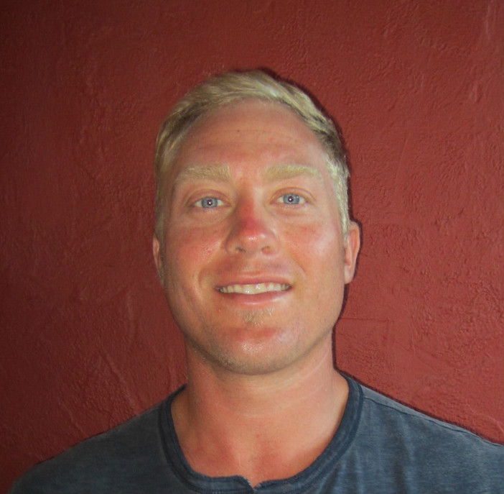

Ryan McLean – English Teacher

Date of Birth August 11, 1983
Nationality USA
Location San Diego, Ca

Career Objective
Loyal and skilled individual interested in instructing the worlds universal
language of English. My priority is to make conversations fun and informative all while
bringing my vast knowledge to the classroom setting.

Licenses and Certificates

- BSc American Public University Sport Science 2011
- STCW-95, ENG 1-2011

- Red Cross Lifeguard Certified 2010

Teaching Experience

Overtime Athletics Education- After school sports education programs designed to improve skills in a variety of sports ranging from 8-15 years. Coached and spoke to students assessing fundamentals of sports. Each week we educated children on health and wellness issues with an emphasis of sportsmanship and team camaraderie. Oct. 2007-2012.

YMCA After School Programs- Taught physical education classes to students ranging from 8-17 years of age. Field trips, Food service, Swim lessons, Taught physical education. May 2001- Oct. 2007.

Skills and Interests
Teaching, Travel, Diverging into other cultures, Food tasting, Surf Instruction, Cooking, Bartending, Massage, Music, Snowboarding.

