David Y. Riddel |  | 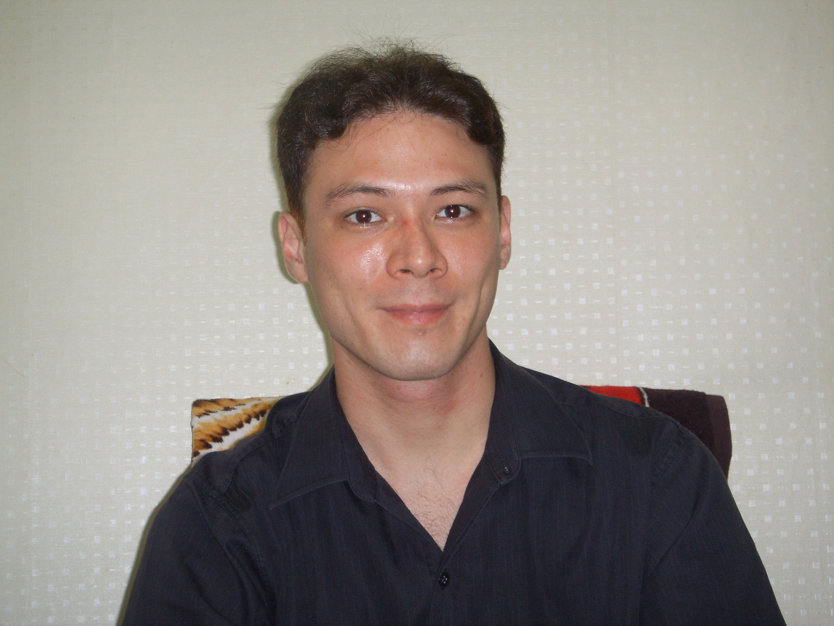
517-47 Gongneung-Dong, Nowon-Gu, Seoul 139240
Tel. 010-5803-2335
theriddelofdavid@yahoo.com

Objective | To obtain a position teaching English in South Korea
Employment  History | - Taught private lessons in Korea and China for a period of 2 years (references available upon request)
Education | 3 years completed of B.A. Degree in English  University of Maryland UC, Adelphi, MD, U.S.A. 3.74 G.P.A. |  | 2005-2008
 | TEFL Certificate in Business English  TITC, Phuket, Thailand |  | 2007
 | TEFL Certificate  ITTT, Phuket, Thailand |  | 2006
Skills | - Computer literate  - Elementary Korean  - Elementary Chinese  - Advanced German
Additional Information | I hold a F-4 visa, allowing me to legally work in Korea.  Transcript, personal picture, and references available upon request.

