Applying for Professional English Tutor

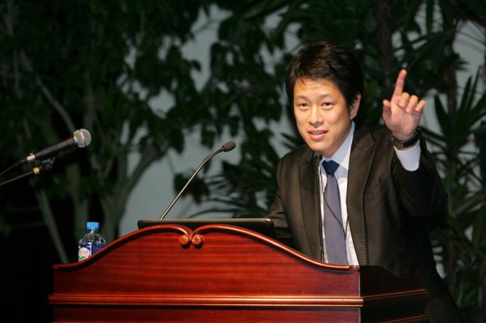

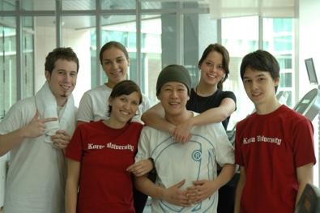

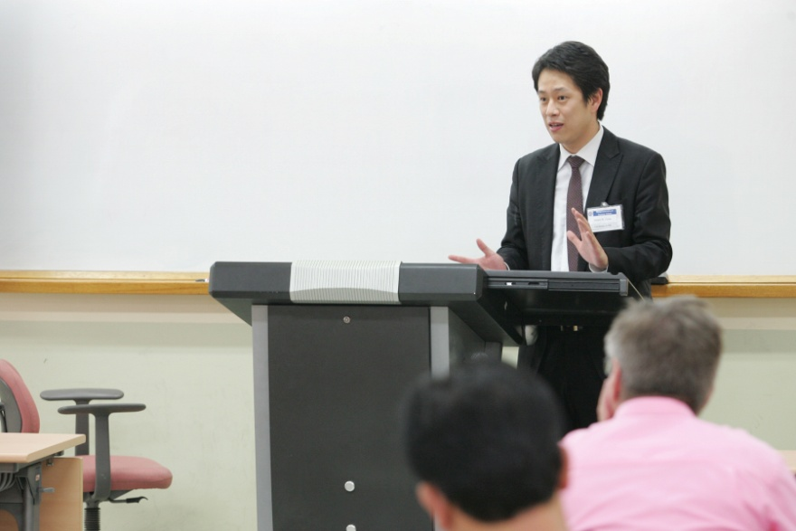

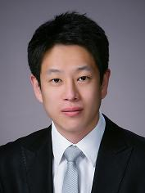

Vincent W. Chung
Cell: 010-8825-7811
E-mail: vince@yonsei.ac.kr
102-140, Hwagok-Dong, Gnagseo-Gu, Seoul, Korea.

Curriculum Viate

◆ Personal Data
- Gender: Male
- Name: Vincent W. Chung (정우경)
- Permanent Address: 102-140, Hwagok-Dong, Gnagseo-Gu, Seoul, Korea.
- Date of Birth: November 22nd, 1978

◆ Job Objective
- As I am bilingual in English and Korean, I am seeking a position of a professional English tutor at your institute, full-time occupation.

◆ Profile
- Learned English at Continental Elementary School in Jeddah, Saudi Arabia, and moved into Korea at Middle School period. Also, tought English in Saipan, USA for 3 years.

◆ Skills
- Fluent in both English and Korean.

◆ Experiences

- April, 2010 ~ October, 2010 (7 Months)
- Coordinator of Yonsei International Summer School, Yonsei University

- August, 2007 ~ March, 2010 (56 Months)
- Global Marketer of Petrochemical Plant Cunstruction Company, Sewon Cellontech, Co., Ltd.

- August, 2006 ~ July, 2007 (12 Months)
- Personal English Tutor, Freelancer

- August, 2005 ~ July, 2006 (12 Months)
- Administrative Staff of Foreign Language Institute, Korea University

◆ Education
- Bachelor’s Degree of Business Management at Korea University, August, 2005

◆ References
- Available on request

