CURRICULAM-VITAE

Name: Ps.YAM BAHADUR KHATRI
Sex: Male
Child: Son-1
Date of Birth: 24-04-65
Address: Gokarna-7, Kisinggal, Utterbahini Chowk Kathmandu.
GPO BOX NO: 19852, Email: yamkc2002@yahoo.com
Nationality: Nepalese
Profession: Pastoral

Skill in Language:
Nepali, Hindi, English, Korean, Urdu, Arabic.

Qualification: (i.) S.L.C. Passed- Board of Nepal in 1983.
(ii) I.A.-Gorkha Military Inter College Dehradun, India at
1986.
(iii) B.A. Tribhuwon University of Nepal- 1993.
(iv) M.A. International Theological University, Pasadena,
California, USA- 2004.
(v) M.Div. Asia Evangelical College & Seminary, India-
2005.
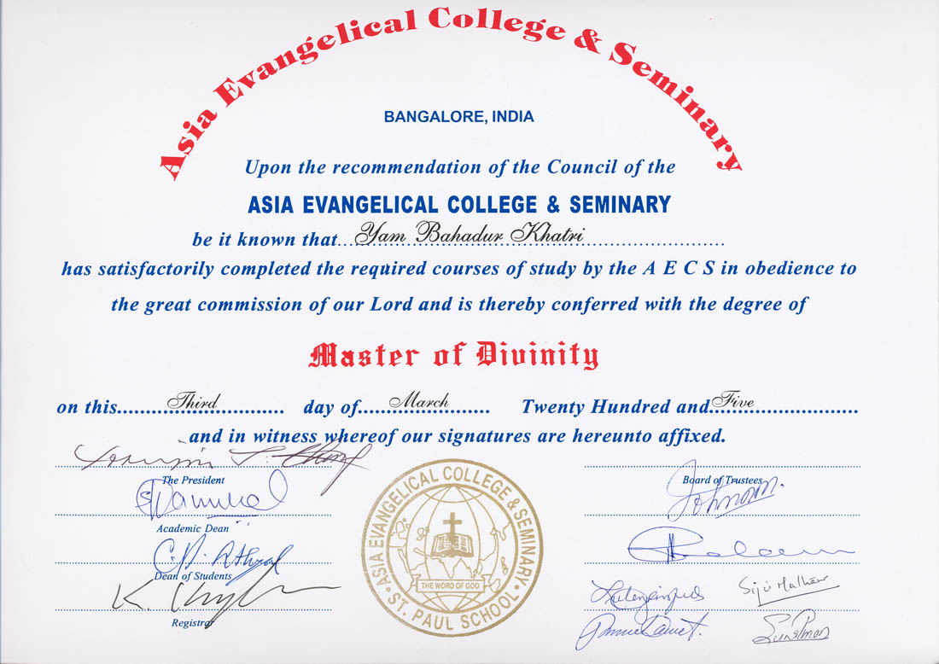

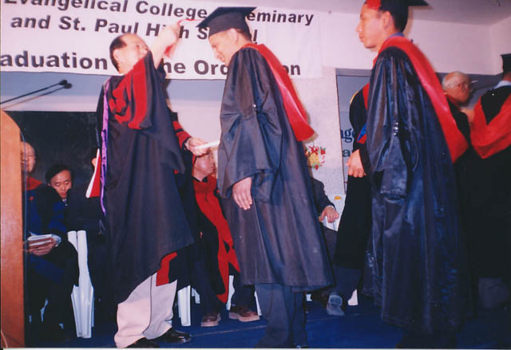
M.Div. Seminary Graduation at Bangalore, on May 3rd 2005.

(vi) Computer Engineer (IT Manager)-CSE Nepal- 2003.
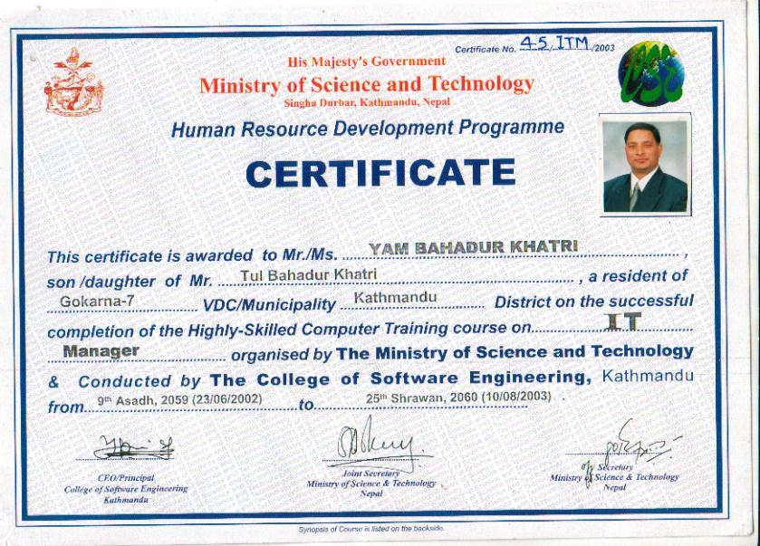
(vii) Korean Language- Graduation- Kon Kuk Univeersity,
South Korea- 2000.
(viii) Advanced in English writing-Graduation-Tribhuwon
University Campus of International Languages.-2003.
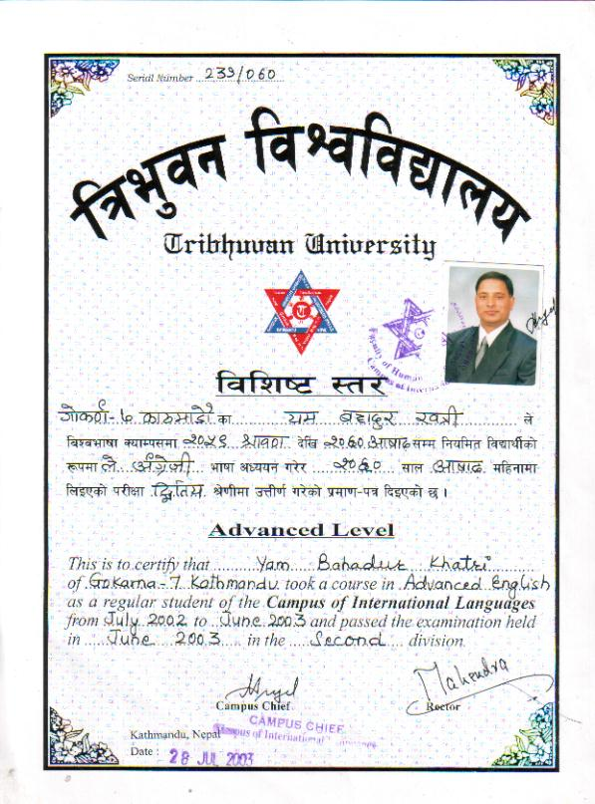

Experiences:

- Marketing officer Management.
- Participate foreign parish activities, healing crusade, conference, seminary, Missionary in South Korea.
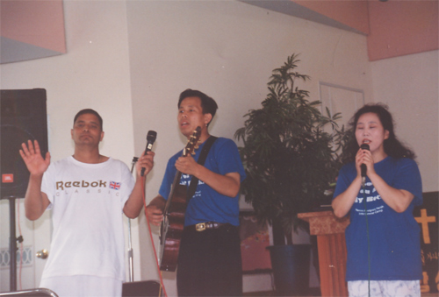

(III) Teaching for High School Students, and Computer, and other technical jobs in Korea.
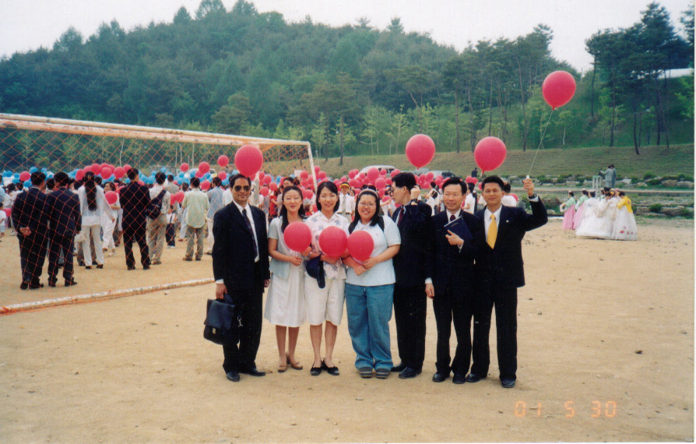

(iv) Instructor Korean Language in Tribhuwan University
Campus of International Languages.
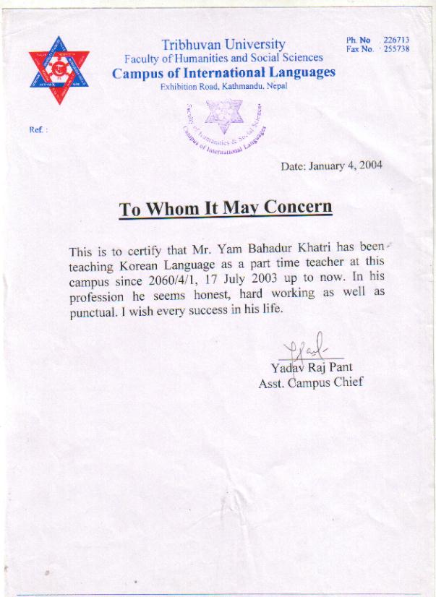

Ministry Experiences:
(i) Serving in Christ among Youth worker/Pastor and Cell
group leadership Kathmandu New Apostolic Bethel
Church, Kathmandu Nepal.
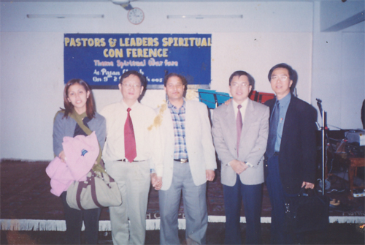

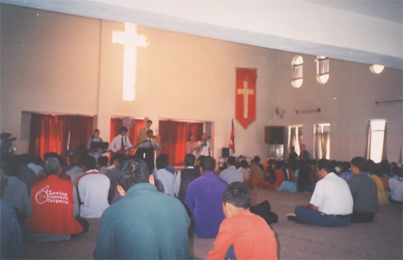
Chapel in New Bathel Church while servicing as copastoral.

(ii) Church Coordinator, Bible teaching, and copastoral since
Dec. 2001 to Jan 11 2005 in Kirtipur Christian
Fellowship, Kirtipur Kathmandu, Nepal.
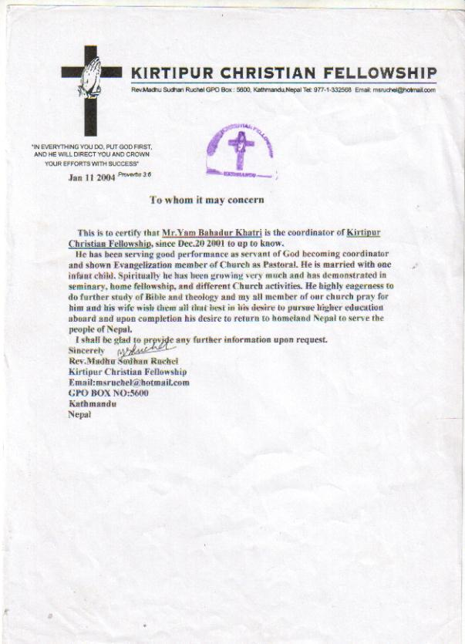

(iii) Campus Representative of International theological
University of USA in Nepal since, 8th Dec. 2004 A.D.

- Senior Pastor of Gokarna Fellowship Kathmandu
since 1st Jan. 2005, Gokarna-7, Kisinggal, GPO 19852, Kathmandu, Nepal.
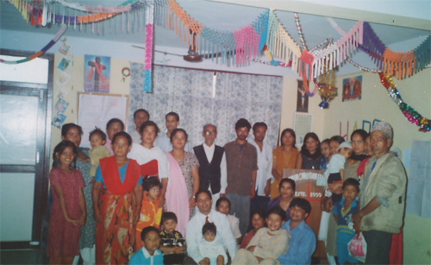
- Visited countries India, Pakistan, Dubai, Saudi Arabia,
Thailand, China, Hong Kong, and Korea.

(vi) Currently, has been lecturing in NEB College, and Gum Bible training, Nepal.

