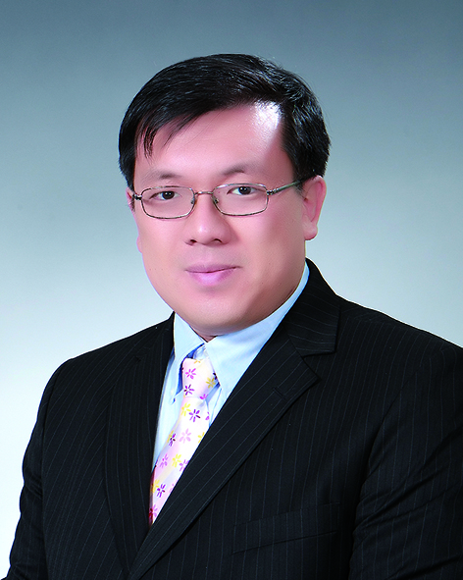
David Oh
Gangwon Province, Jeongseon County, Imgye Township
Seongjae 6 Road, Dongsan Apt. Gadong #105
010-4459-2215

PROFILE
(DOB February 15, 1975)
I have been in education for almost nine years. I enjoy teaching English and experiencing different cultures, so I decided to pursue a career in teaching English in foreign cultures. I started as a substitute teacher in California, U.S.A., from there I went out to China and worked for two years, and most recently in Korea, now for more than 7 years. In addition to my years of experience teaching EFL, I took a course on TEFL in 2007 and I now have a TEFL certificate.

EDUCATION

Korea Education Institute - Cheongpyeong, S. Korea
Certificate- TEFL 100 hours
Received 07/25/2007

University of California at Irvine- Irvine, California
Certificate- TEFL Training for Teaching Abroad Program (50 Hours)
Received 06/22/2005

Biola University - La Mirada, California
Bachelor of Arts - Psychology
Graduated 12/17/1999

PROFESSIONAL ORGANIZATION

Active member of KOTESOL (Korea Teacher of English to Speakers of Other Languages) since April 2012; participated in most seminars and conferences

TEACHING EXPERIENCE

Gangwon Province Office of Education- Jeongseon Office of Education, Jeongseon County, Gangwondo; Samchoek Office of Education, Samcheok City; S. Korea August 2008 — present.
EFL Instructor - Imgye Middle & High School (August 2008 – August 2009; August 2010 – present) Miro Middle School, Sodal Middle School (August 2009 – August 2010)
• Provided native English education through various lessons, games and activities to middle and high school aged students, non-native English teachers, non English teachers, and school staff members.
• Organized and instructed English education camps during school vacation times and on certain weekends.
• Judged debate and speech contests.
• Evaluated student and teacher papers.
• Presented open class lessons to other native and Korean English teachers.
• Participated in voluntary in service teacher training sessions.
• Advised new native teachers on lesson planning, classroom management and organization procedures.

Incheon Metropolitan City Office of Education (Seobu branch), Incheon, S. Korea September 2005 — September 2007
EFL Instructor - Seogot Middle School (September 2005 - August 2006) and Gyesan Girls’ Middle School (August 2006 to August 2008)
• Provided native English education through various lessons, games and activities to middle school ages students, non-native English teachers, non English teachers, and school community members.
• Judged debate and speech contests.
• Evaluated student and teacher papers.
• Presented open class lessons to other native and Korean English teachers.
• Provided after school extra-curricular English classes to interested students.
• Provided Saturday English lessons for community children at a local park.

Meysen-Star River, Shanghai, P.R. China September 2003 — March 2005
EFL Instructor - Primary age children at various public schools in Shanghai
Continued on back of page…
• Provided American English Phonics and Phonemic Awareness, English music, and vocabulary expansion instruction in large classroom environment.
• Managed primary aged classroom environment.

Pei Zheng Commercial College- Huadu City, Guangzhou County, P.R. China, April 2003 — July 2003
Conversational English Language Instructor
• Conducted classroom instruction of proper oral English language usage
• Provided native English language conversational ability to improve Chinese student’s English
• Interacted with Chinese students outside of classroom to learn Chinese culture and provide opportunities to speak with a native English speaker

Westminster & Fullerton School Districts - Westminster & Fullerton, CA - May, 2001 — March, 2003
Substitute Teacher
• Continued student’s education during regular teacher’s absence
• Managed multiple classroom environments- Kindergarten through 8th grade, special education classes in both ele-mentary and junior high schools
• Mediated conflicts between students

NON-TEACHING WORK EXPERIENCE

Barnes & Noble Booksellers - Huntington Beach, California - August, 2000 — November, 2001
Bookseller (part time)- Sales and Customer service
• Received good customer service comment cards
• Handled cash receipts
• Assisted customers in book selection
• Trained new hires

Interplay (MacPlay) Productions - Irvine, California - October, 1995 — August, 1996
Software Beta Tester - Quality Assurance
• Detected and reported anomalies in software programs
• Assisted programmers in software improvement

Computer City - Cerritos, California - December, 1994 — June, 1995
Sales Associate - Floor Sales
• Assisted customers in product selection
• Demonstrated product features to customers
•Organized and maintained product displays

EXTRA CURRICULAR & VOLUNTEER ACTIVITIES

Imgye Methodist Church, Jeongseon County, Gangwon Province, S. Korea- November 2012 – present
English Bible study teacher
New Song Community Church, Irvine, CA, USA- November, 2001 through March 2003
World Missions Department volunteer
Dong Shin Presbyterian Church College Ministry, Fullerton, CA, USA - December, 1998 through June, 1999
Community Outreach Team Coordinator
Serving Other Nations Ministry Fullerton, CA, USA- February, 1998 through August, 1998
Short Term Mission Team Member
Young-Nak Presbyterian Church of Orange County, Garden Grove CA, USA- July, 1997 through Nov., 1998
Sunday School Teacher

SKILLS

Intermediate knowledge of Korean language
Advanced Macintosh computer skills
Literate in Microsoft Windows 95, 98, 2000, ME, XP
Working knowledge of Microsoft Word, Excel, Power Point, Adobe Photoshop, desktop publishing software

PERSONAL INFORMATION

Hobbies & Interests: Traveling, astronomy, light reading

Travels: Born and lived in Brazil (total of 5 years), worked in PR China (2 years), South Korea (7 years); visited Philippines, Thailand, Hong Kong, Macau, Japan, Pakistan, and Mexico

