Resume of Tim Sauder:

Objectives:
management position for business or teaching
Personal information:

Timothy Sauder:
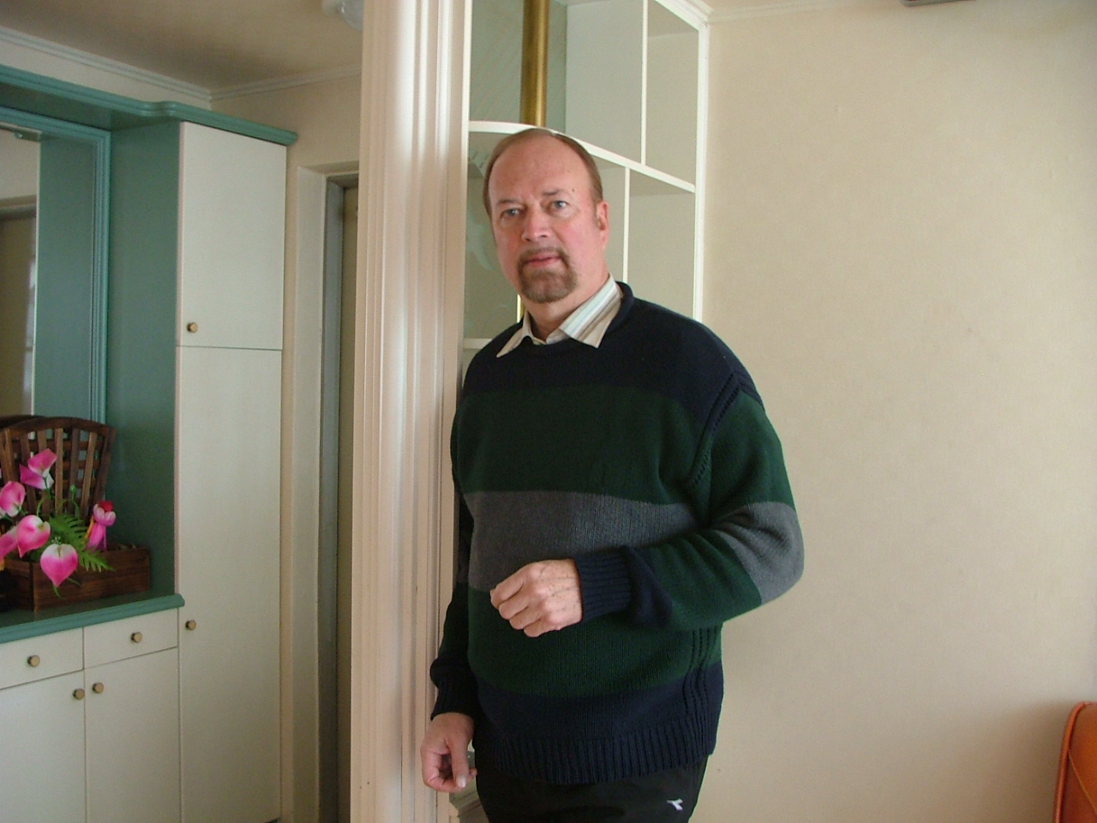

- Statistics:
- Born Kitchener Ontario
- August 22, 1957
- Canadian –
- Detail:
- Married

Summary: Background experience
- Timothy Sauder has owned several businesses mostly related to the kitchen cabinet sales design and installation. Recently he has operated a cabinet installation business in Florida. He lived and owned a retail kitchen business in Canada for 23 years. In the early 90’s he was trained in Texas by Ron Willingham’s organisation ‘Sales training Inc.’ Of Integrity Selling. Certified as a trainer instructor in both sales and customer service he owned Corporate Dynamics of Canada.
- His background and training as a Mennonite pastor and church planter makes him an excellent public speaker.
- In the 70’s and 80’s he was involved in Christian ministry and evangelism on university campuses with several organisations.
- He is a graduate of Oral Roberts University 1973 with a liberal arts degree B.A. Post Graduate studies in business management from University of Waterloo Conrad Grebel College.

TOOLS OF THE TRADE –Educational background

*Four years of theology Mennonite studies form Emmanuel Bible College
Kitchener Ontario. Diploma 1970. Accredited Degree 1983.
- B .A. Biblical literature degree Oral Roberts University 1973.
- Post Graduate studies in management and Church Government
Conrad Grebel College in conjunction with Associated Mennonite Biblical Seminaries.
Certificates in Integrity Selling in Texas with Ron Willingham
Customer Service:trainer and teacher.
Grief Counselling with :John Cherry from California.

Creative ministry school :of Youth with a Mission Canada

History of Experience:

Korea: one year with SDA language institute in Jeonju Korea. 2007-2008.
Student evaluations were the highest in the schools history.

- 2005-2007 Owner manager of an installation company in Florida providing the installation of Kitchen cabinets for various companies. As such he was in charge of Job management and co- ordination. Provided problem solving for other companies in management.
- 1983-2004
- He was the owner and manager of ‘Sauder Design’ kitchen design and sales company in Canada.
- Developer of a new format for granite countertops and importer of stone premade for the Canadian market. He developed a dealer network for this product and did training for the dealers in both the installation and sales.
- 1988-1989
- He managed an assembly plant for kitchens in Florida for a Canadian company. He was in charge of hiring and managing all personal and directing all sales. The company was prepared for to sell and the owner made a huge profit from the sale.
- In1990 He received certification with ‘sales training inc.’ in Texas. Later this was used in Canada to start and operate ‘Corporate Dynamics of Canada.’ This was to give and sell human resource development to the general work place. During this time he was also certified in grief recovery both to train and sell the program to hospitals and other professional persons.
- 1969-1973
- During this time he received two accredited degrees for Christian ministry and also for Liberal Arts.
- 1973-1984
- He was involved in Ministry in various organizations. Training young people and counselling. Involvement at this time was also with Youth with a Mission as a leader trainer.
- Speaks Spanish and English.

In preparation for a possible return to teaching English in Korea he has the police report and health report up dated to Oct. 2008. He and his wife have no dependent children and can travel anywhere. With the wide range of experience in management skills and teacher training plus counselling skills he is ready for any job that requires these area’s of expertise.
See Resume of Reina Fuentes de Sauder: Degree in Human Resources worked assistant to the Prime minister in the authorial department.

