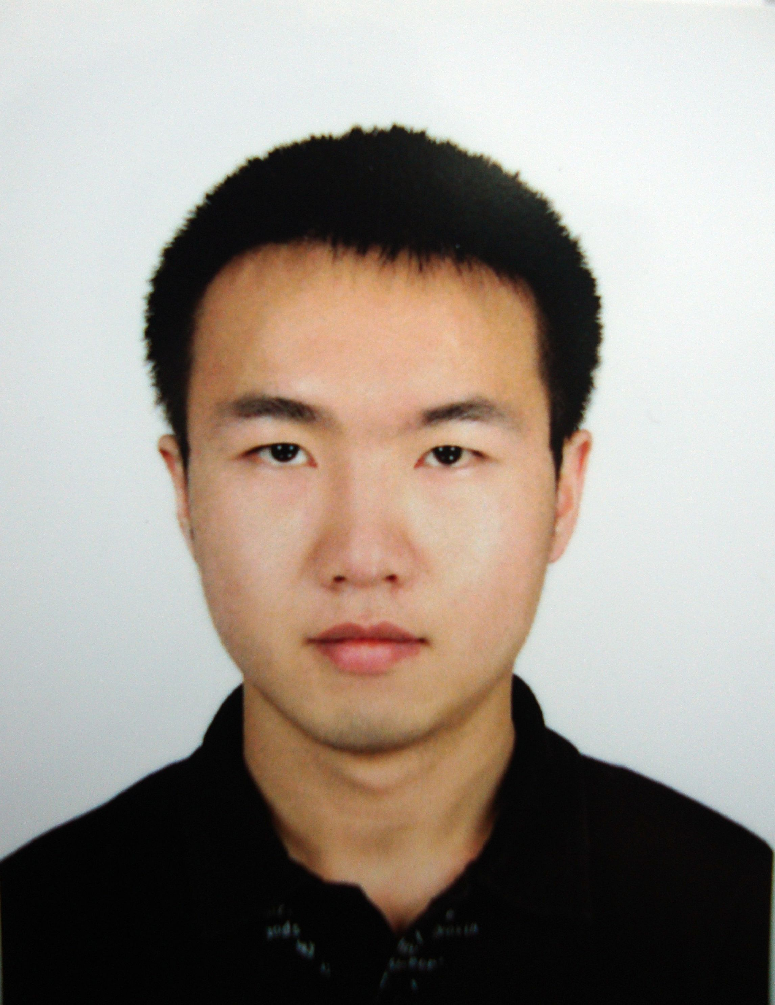

Harley Liu

Kyungsung University,
Busan, South Korea
010-8231-8558 sichuanliuqi@hotmail.com
Talented young professional with skills and training in:
Finance and Business study
PROFILE
- Awarded 2007 Business Marketing Competition
- Received 2008 Service Award for outstanding contributions to campus activities
- Fluency in Chinese and English. Technically proficiency in MS Word, Excel and PowerPoint, Programming in C Language, Wed design.
- Energetic and Enthusiastic
EXPERIENCE
- Part-time job as manager assistant in a hotel
- Volunteer in neighborhood service
EDUCATION
- Junior undergraduate, Majoring in Finance, Northeastern University of China
- 2 years exchange student experience in Kyungsung University in South Korea
PRESENTATIONS
- Presentation of the Present Situation and Expectation of the Relationship Between China and Korea

The enclosed resume describes my qualifications for the position advertised. I would welcome the opportunity to personally discuss my qualifications with you at your convenience. Thank you for your time and consideration.

#625, BLDG. 28
Kyungsung University
Busan, South Korea
Dear Ms./Mr.:
Your advertisement for a English teacher on the website interested me because the position that you described sounds exactly like the kind of job I am seeking.
According to the advertisement, your position requires fluently speaking ability or above in English or equivalent field and proficient in teaching system. I feel that I am competent to meet the requirements. I will be graduating from undergraduate School of Northeastern University and Kyungsung University this year. My studies have included courses in Business administration and Finance. But the point is, all my classes are in English and all my professors are from Canada and America. So, English has become my mother tongue in Korea, no matter in school or in everyday life.
During my education, I have grasped the principals of my major and skills of practice. Not only have I passed CET(College English Test)-6, but more important I can communicate with others freely in English. My ability to write and speak English is out of question. I also had experience in teaching English in Korea. In Kyungsung University, I teach college students English so they will be prepared to study abroad in the future. This kind of experience will help me in doing a good job in teaching English.
I would appreciate your time in reviewing my enclosed resume and if there is any additional information you require, please contact me. With many thanks,

Harley Liu
