Polycarp Ngu
790-9 Wa-dong, Danwon-gu
Gyeonggi-do, Ansan-si
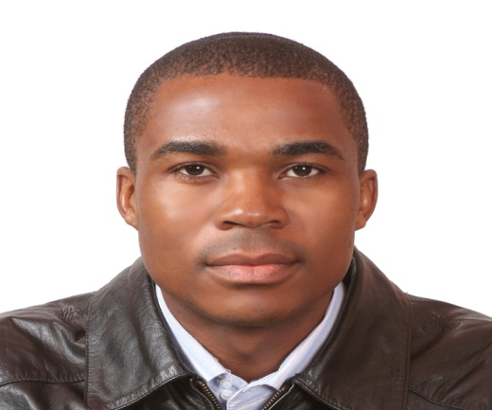
SOUTH KOREA
MOBILE: 010-7263- 0917
E-mail: melcinthngu@gmail.com

QUALIFICATIONS
- Bilingual communication skill, English (first language), French (second language)
- English Tutoring, 2 years.

EDUCATION
2010 Master of Arts, International Trade
Ajou University, Republic of Korea
- Conferment of Degree, 2010 winter commencement
- Dean’s awardee, 2010 winter commencement
- Student Representative, IT Department, Spring Semester 2010
- Teaching Assistant (International Trade Practice), Spring Semester, 2010
- Teaching Assistant (International Commercial Contracts and Disputes Settlement), Fall Semester, 2009
- Editorial Board member, Gazette, semester News
Letter publication of the Graduate School of International Studies, Ajou University

2007 Bachelor of Science, Management
University of Buea
Commencement, December 2007
Second class honors

EXPERIENCE
2009 – Present English Language tutoring, one to one and academies (Korea)

- – 2007 Manager
CANCUN Snack-Bar & Restaurant

LANGUAGE SKILLS LEVEL

English Language Native
French Language Intermediate
Korean Language Beginner

COMPUTER SKILLS LEVEL
Microsoft Words Advanced
Microsoft Excel Advanced
Microsoft Power Point Advanced

AWARDS
Grand Prize of the Fifth English Economic Essay Contest hosted by The Korea Times and sponsored by Woori Bank, November 2, 2009.

Hobbies: Football, In-door games, reading, theater, cooking, social dancing

