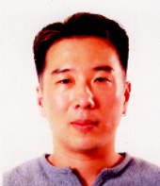 Leonard Yu  인천 남동구 논현동  593-24 304호  010-2824-4357  leonardyu@hotmail.com | Objective  Native English Teacher/ Team Leader/ Head Teacher

Work History
2009~Present Incheon Dongbang Elem. School
Native Teacher-After School Program
(Speaking, Program Development)

2008-2009 Youngjaesakwan, Dongtan
Head Native Teacher
(Speaking, Writing, Toefl, Program Development)

2007-2008 Hansol/ENG O-mokchon, Suwon
(Speaking, Essay Writing)

2006-2007 EBY Talking Club, Deungchon, Seoul
(Speaking, Essay Writing)

2005-2006, Youngjaesakwan, Shinjeoung, Seoul
(Speaking, Toelf/Essay Writing, Ivy Kids)
2004-2005, World Prep School, Naebalsan, Seoul
(Speaking)

2004-2004, Eureka School of English, Apgujeong, Seoul
(Speaking & Grammar)
 | Education
1996-2000 California State University, Carson City, CA
BS Business Administration: Accounting
1991-1992 Academy of Health Science, San Antonio, TX
AS Surgical Technology
 | References are available on request.

