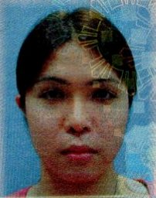
CRIS N. ANICETE
#203-11, Goji-Ri, JungNam-Myeon, Hwasung-Si, Gyeonggi-Do,Korea
Cp # - 010-72176885
shannen_172002@yahoo.com
Objective:
To enhance and apply all my knowledge in the field of Mass Communication

Personal Profile:
Age: 24
Birth of date: December 21, 1986
Place of Birth: Palasan, Valenzuela City
Religion: Roman Catholic
Nationality: Filipino
Civil Status: Single
Height: 5’7’’
Mother’s Name: Lourdes Nugid
Occupation: Deceased
Father’s Name: Carlito Anicete
Occupation: Driver

Educational Attainment:

Tertiary
Adamson University 2004-2008
A.B Mass Communication
San Marcelino Ermita, Manila

Secondary
Torres High School 1999-2003
Gagalangin, Tondo Manila

Elementary
Perpetua R. San Diego Elementary School 1993-1999
Valenzuela City

Special Skills:
- Capable in English Communication both Oral and Written
- Skilled in the use of various MS Office Applications and the Internet
- Graphic lay-out using Adobe Photoshop
- Basic Mathematical Analysis
- Above average in E-mail business writing skills
- Strong Attention to details
- Good Organizational skills
- Willing to learn
- Above average analytical skills
- Team Player
Internships:
Radio Practicum 90.7 Love Radio May 2007
Public Relation Practicum 90.7 Love Radio PR Office May 2007
Print Practicum Hataw Publication May 2007
Television Practicum CBN Asia May 2007

Work Experience:

Senior Customer Service Associate
RR Donnelley
Global Outsourcing Company
East Gate Building, Mandaluyong City
June 2008-December 2010
Character Reference:
* Available Upon Request

