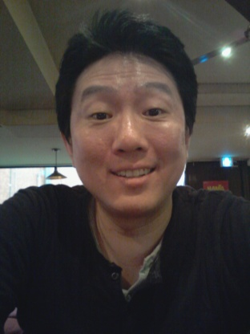

D. Peter Kim
경기도, 광명시, 광명5동, 288-19, 3F
dpeterk@hotmail.com / 010-4786-1970

Dynamic and Energetic Teacher of American English

- Great diction and pronunciation of American English
- Exceptional speaking ability based on experience in media
- High level of professionalism and presentation
- Intermediate fluency in both written and spoken Korean
- Native fluency in American English, completely educated in the U.S.
- Keen attention to detail, high dedication to quality
Teaching Experience: Choi’s Language School 1994-1995
- Taught English conversation mostly to adults

Work Experience: Essay Tutors 2008-2013
- Copy editor for the English-language website of The Dong-A Ilbo.

KBS News 2005-2012
- Voiceover and editorial consultant for the daily English-language program “KBS World News Today.”

Fn Hub Korea (금융감독원) 2010-2012
- Editor and writer for an office dedicated to promoting Seoul as a financial hub of Asia.

Arirang TV News 2006-2007
- Copy editor for the news team

KBS World Radio 2005-2006
- Wrote stories, edited copy and read news

The Korea Development Bank (산업은행) 2000-2002
- Served as the communication officer of the bank and investor relations team

The Korea Herald 1998-1999
- Wrote stories for the weekly magazine Newsreview and sports articles for the newspaper.

Yonhap News Agency 1995-1997, 1999-2000
- Edited news copy and covered news for the English-language news department.

Education: University of Maryland, College Park, MD 1992
- Bachelor of Arts, Sociology.

