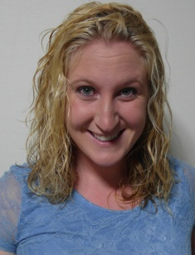

Pamela Canfield

Objective:
- To help children learn English so that their future will be full of opportunities while experiencing and respecting their culture. Learning English should be fun and exciting.
Education:
Bachelor of Science in Political Science
Francis Marion University, Florence SC
May 2008
GPA: 3.3
Honors:
  - Pi Sigma Alpha Honor Society
  - President’s List
  - Dean’s List

ESL Teaching:
Private English Academy in Korea
One year (May 2010-May2011)
Taught elementary to middle school students speaking and writing.
Mainly worked with the 8 to 12 year olds
English Island
August 2011 –September 2013
Kindergarten Head teacher
Teaching 7 year olds (Korean Age) and assisting and occasionally teaching 6 year olds. I have also taught at Academy, teaching first to sixth graders.
Teaching Experience:
- Currently:
  - Teaching 7 year olds (Korean Age) and occasionally teaching 6 year olds.
  - Academy, teaching first to sixth graders as a substitute.
  - Teaching adults speaking, reading, writing, and listening.

- Teaching in Korea:
  - Teaching elementary to middle school students speaking and writing.

- High school:
  - Helping elementary students that were behind in English and other subjects.
  - Home schooled my younger sister.
  - Taught Sunday School lessons to children
- College:
  - Group research and presentations
- Law school:
  - Member of a study group where each member had to come up with creative ways to teach the different laws

Work Experience:

- ESL Teacher
Yeongju, South Korea
August 2011- September 2013
Daegu , South Korea
May 2010- May 2011
- Twelfth Judicial Circuit Solicitor’s Office
Florence, SC
Intern- Spring of 2008
- Billy’s Superstore
Trenton, SC
Cashier-Summers of 2003 to 2008
Manager 2008-2009

Volunteer:
- Reid Park Elementary, Charlotte NC (2009)
  - Prepared classrooms for teachers
- University Programming Board, Francis Marion University (2005-2008)
- Wesley Foundation, Francis Marion University (2005-2008)
- Student Alumni Association,Francis Marion University(2006-2008)
- Baptist Collegiate Ministries, Francis Marion University(2006-2008)

Hobbies:
- Playing sports
- Arts and crafts
- Hiking
References: Available upon request.

