KEITH LEVESQUE
__________________________________________________________________________________________________________

United States Address: Current Korean Address:
1114 North Main St. Apt #1 Jeonju, Jeollabuk-do, South Korea
Fall River, MA 02720 USA (cell) 010-5585-7658
    - keithlevesque83@yahoo.com

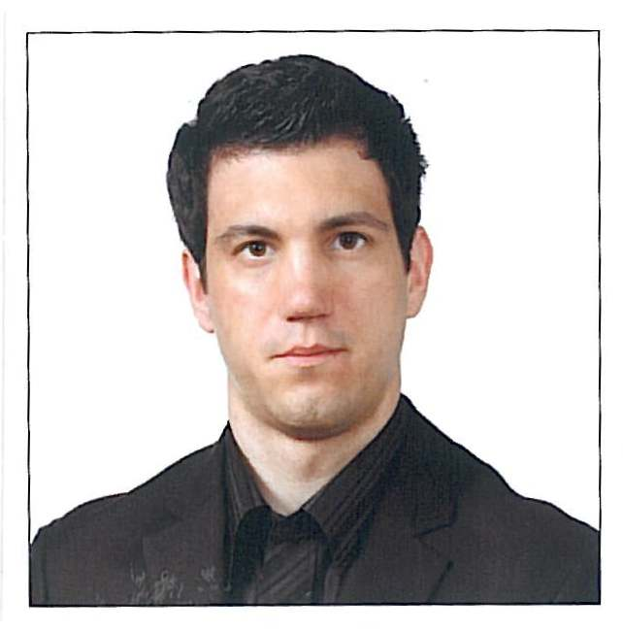
PERSONAL:

Date of Birth: March 22, 1983
Place of Birth: Westport, MA, USA
Citizenship: USA
Spoken Languages: English

PROFILE: I enjoy teaching adults and children and have done so for two years in Korea. I am very kind, generous, and have good organizational skills. I enjoy writing and playing bass guitar. I also enjoy traveling and living in foreign countries. I have lived in Korea for two years and have traveled to Japan, Taiwan, China, Spain, Philippines, Canada, and many places in the USA.
I have a bachelor’s degree in English: Creative Writing, Communications, and Rhetoric from the University of Massachusetts Dartmouth. I have also completed many training courses in Korea supported by both the North Jeolla Province and Jeonju city education offices. I also have an online TESOL certificate from ITTT (120 hours).

OBJECTIVE: To teach English and gain teaching experience.

EDUCATION: University of Massachusetts Dartmouth
BA in English, Writing, Communications, and Rhetoric

ITTT University
120 hour TESOL certificate

Bristol Community College
AS in Liberal Arts

EXPERIENCE: 2008 - Present
Jeonju English Center: Jeonju, Jeollabuk-do, South Korea
Guest English Teacher
-Teach elementary and middle school students as well as adults from parents to Korean teachers.
-Make lesson plans, worksheets, organize various teaching programs.
-Teach writing, conversation, reading, and grammar.
-Conduct free talking classes and help choose curriculum.
- Various programs include; Elite program, weekend program, weekday program for both 5th and 6th grade, Parents program, Teacher Program, Adults Program, and Winter and Summer vacation programs, and workshops such as Model Town and Plays.

2007 - 2008
OnProcess Technology: Ashland, MA, USA
Logistics Service Representative
-Daily tasks include; calls out, receiving calls, email and fax.
-Use UPS website to generate shipping labels and tracking numbers, In charge of overseeing the
export of daily shipments.
-Conduct daily tasks using Microsoft Office, Word, Excel, Access and Outlook
-Trained in twelve programs primarily; SonoSite, Cisco, Dell, and Direct TV, also went through
Asurion certification/training.
-Multitask in fast paced environment using four or more programs as well as using specific
program web tools like; Cisco ART tool, Comcast Activations tool, and SonoSite Ultrsound
Upgrade tool.

2006 - 2007
Catholic Memorial Home: Fall River, MA, USA
Cook and Kitchen Supervisor
- Train and direct activities of other workers who assist in preparing and serving meals.
- Assure that all sanitation and safety standards are met.

ASSETS:
- 2 years of teaching experience
- 2 years of experience making lesson plans, worksheets, and curriculums
- 7 years of customer service experience
- 4 years of managerial and training experience
- Proficient knowledge of Microsoft Office (Word, Excel, Access, & Outlook)
- Ability to work both independently and collaboratively
- Excellent time/project management ability
- Excellent attention to detail and dedication to accuracy

References and Transcripts: Available Upon Request

