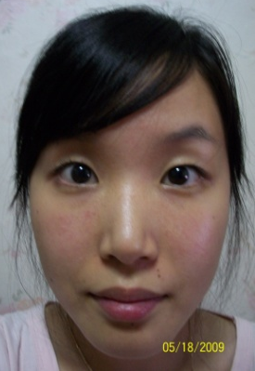

Naomi Sujin You

Email: imoan35@hotmail.com
Mobile: 010 2579 0545

Languages: English
Korean

Education
Bachelor of Education in Adult Education, University of Western Sydney 2006-2009

Employment History

English tutoring
2005 to date.
- Planning and developing weekly lessons and activities for students depending on the relevant age group.
- Teaching English.

St. Vincent De Paul
2007-2005
- St. Vincent de Paul’s Society aiding people experiencing homelessness.

Teaching English to Adults
2007
- Lesson planning with partner teachers as well as teaching English to a small group of students.
- Engage in discussions

Biblical leadership
2007– 3 months
- Biblical leadership for a small youth cell which required weekly social interactions.
- Engage in discussions
- Foster a positive and caring environment

Translating and interpreting
2006
- Providing translating and interpreting services for a mission centre.

YWAM group leader
2005 – 2003
- Annual mission trips to different countries.
- Using and developing both leadership and social skills.
- Engage in discussions

Key Competencies

Communication skills:
Teaching experience, speeches and leadership roles have developed my communication skills, enabling me to utilise my strengths as a speaker to convey my knowledge and opinions.

Ability to adapt to my situation:
I am able to adjust my techniques used in, teaching lessons and interactive sessions in response to students' reactions and input. This allows me to shape sessions more efficiently around the specific situation without losing pace or effectiveness of the class.

Bilingual ability:
My Korean descent has given me the advantage of being capable in communicating in the Korean language. Also as I was born and raised in Australia I possess the native level of language awareness in English. I can apply this advantage in situations where no alternative is available, in cases that English speakers cannot facilitate.

References

References available upon request

Additional information
Currently holding both Korean and Australian citizenships.

