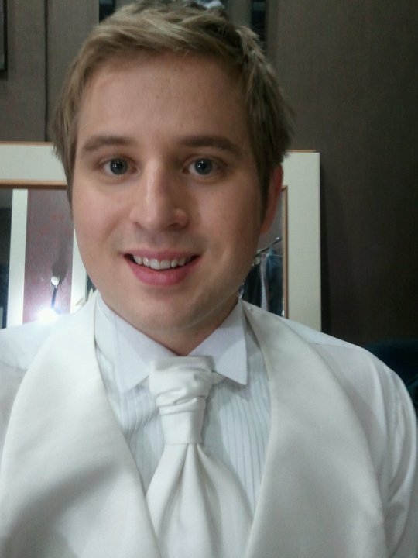

Matthew Howard Wight
Email: yourhero777@hotmail.com
Phone #: 02-6061-5446

OBJECTIVE

I would like to find a Middle School, High School, or University position. I’m qualified and experienced to teach at the Intermediate and Senior level. I would expect to work for a school that has good management and is professional dealing with people who are qualified and experienced. I have an English and Education degree as well (BA/BED). Not to mention, I’m a happily married man with my F2 visa.

SKILL SUMMARY

- Understands Korean culture
- Understands the students needs
- An effective educator
- Shows compassion to the students
- Has excellent teaching skill
- Works well with others
- Motivates students to learn
- Has a great personality
- Is a strong leader

EDUCATION

1998-
2002

Sir James Dunn Collegiate and Vocational School
Sault Ste. Marie, Ontario, Canada
*Completed Grade 13

2002-
2007
Lakehead University
Thunder Bay, Ontario
*Earned a degree in BA/BED (Degree in English and Education at the Intermediate and Senior level)

WORK EXPERIENCE

March 2012- Teacher
March 2010 English Heritage
Seoul, South Korea
010-3310-5767

October 2008- Teacher
October 2009 Sinpyung Middle School
Hanam City, South Korea

March 2007- Student Teacher
April 2007 William Merrifield Public School
Sault Ste. Marie, Ontario, Canada

December 2007- Student Teacher
December 2007 Sir James Dunn Vocational School
Sault Ste. Marie, Ontario, Canada

May 2004- Carpenter/Labourer
September 2007 Wight Construction
Sault Ste. Marie, Ontario, Canada

May 2003- Sales Representative
September 2003 CUTCO
Thunder Bay, Ontario, Canada

May 2002- Entrepreneur
September 2002 Matt’s Firewood
Sault Ste. Marie, Ontario, Canada
*Ran my own business through a Summer Company Program
*This was a student entrepreneurship training program ran by the Ministry of Enterprise, Opportunity and Innovation

July 1997- Carpenter/Labourer
September 2002 Wight Construction, Sault Ste. Marie, Ontario, Canada

July 1996- Paper Delivery Service
September 1997 Sault Star
Sault Ste. Marie, Ontario, Canada

AWARDS/ACCOMPLISHMENTS

- Received a certificate from GEOLINK EDUCATION (teacher training/fulford training) in 2010
- Bungee Jumped for the first time ever 2009
- Completed a contract in Korea
- Has been to the Great Wall of China 2008
- Received a number of Certificates of Appreciation for Readers are Leaders (tutoring young children) 2002-2005
- Successfully completed “Summer Company” 2002-2003
- Volunteered for Ontario Winter Games 2000-2001
- Received second all-star team award, won league champions, city champions, N.O.S.S.A, Montreal tournament, and competed at O.F.S.A.A in hockey at Sir James Dunn 2001-2002
- Named Captain of Sir James Dunn Hockey team 2001-2002
- Drafted to Ottawa 67’s in the OHL 1998-1999

INTERESTS

- I love playing such sports as hockey, baseball, and golf.
- I love socializing with friends
- I love travelling and meeting new people.
- I love writing and creating music.

REFERENCES: Available upon request

