To whom it may concern,
My name is Matt McCallum, and I am a certified ESL/TESOL teacher. I am particularly interested in teaching jobs in the Yangju area. I am recently finished a year long contract teaching children ages 8-13 in Uijeongbu, and I am willing to teach any age group or skill level. I will be available to begin work in the middle of August 2010.
In May of 2008, graduated from a private college in the United States with a degree in history, and a minor in biology. I completed my ESL certification coarse in Costa Rica, in March of 2009. I have extensive work with children of all ages, not just in teaching, and look forward to applying my skills and knowledge at your institution.
Please feel free to contact me via email, if you have further questions, or if you would like to set up an interview time.
Thank you for your time, and I look forward to hearing from you.
Sincerely,
Matt McCallum
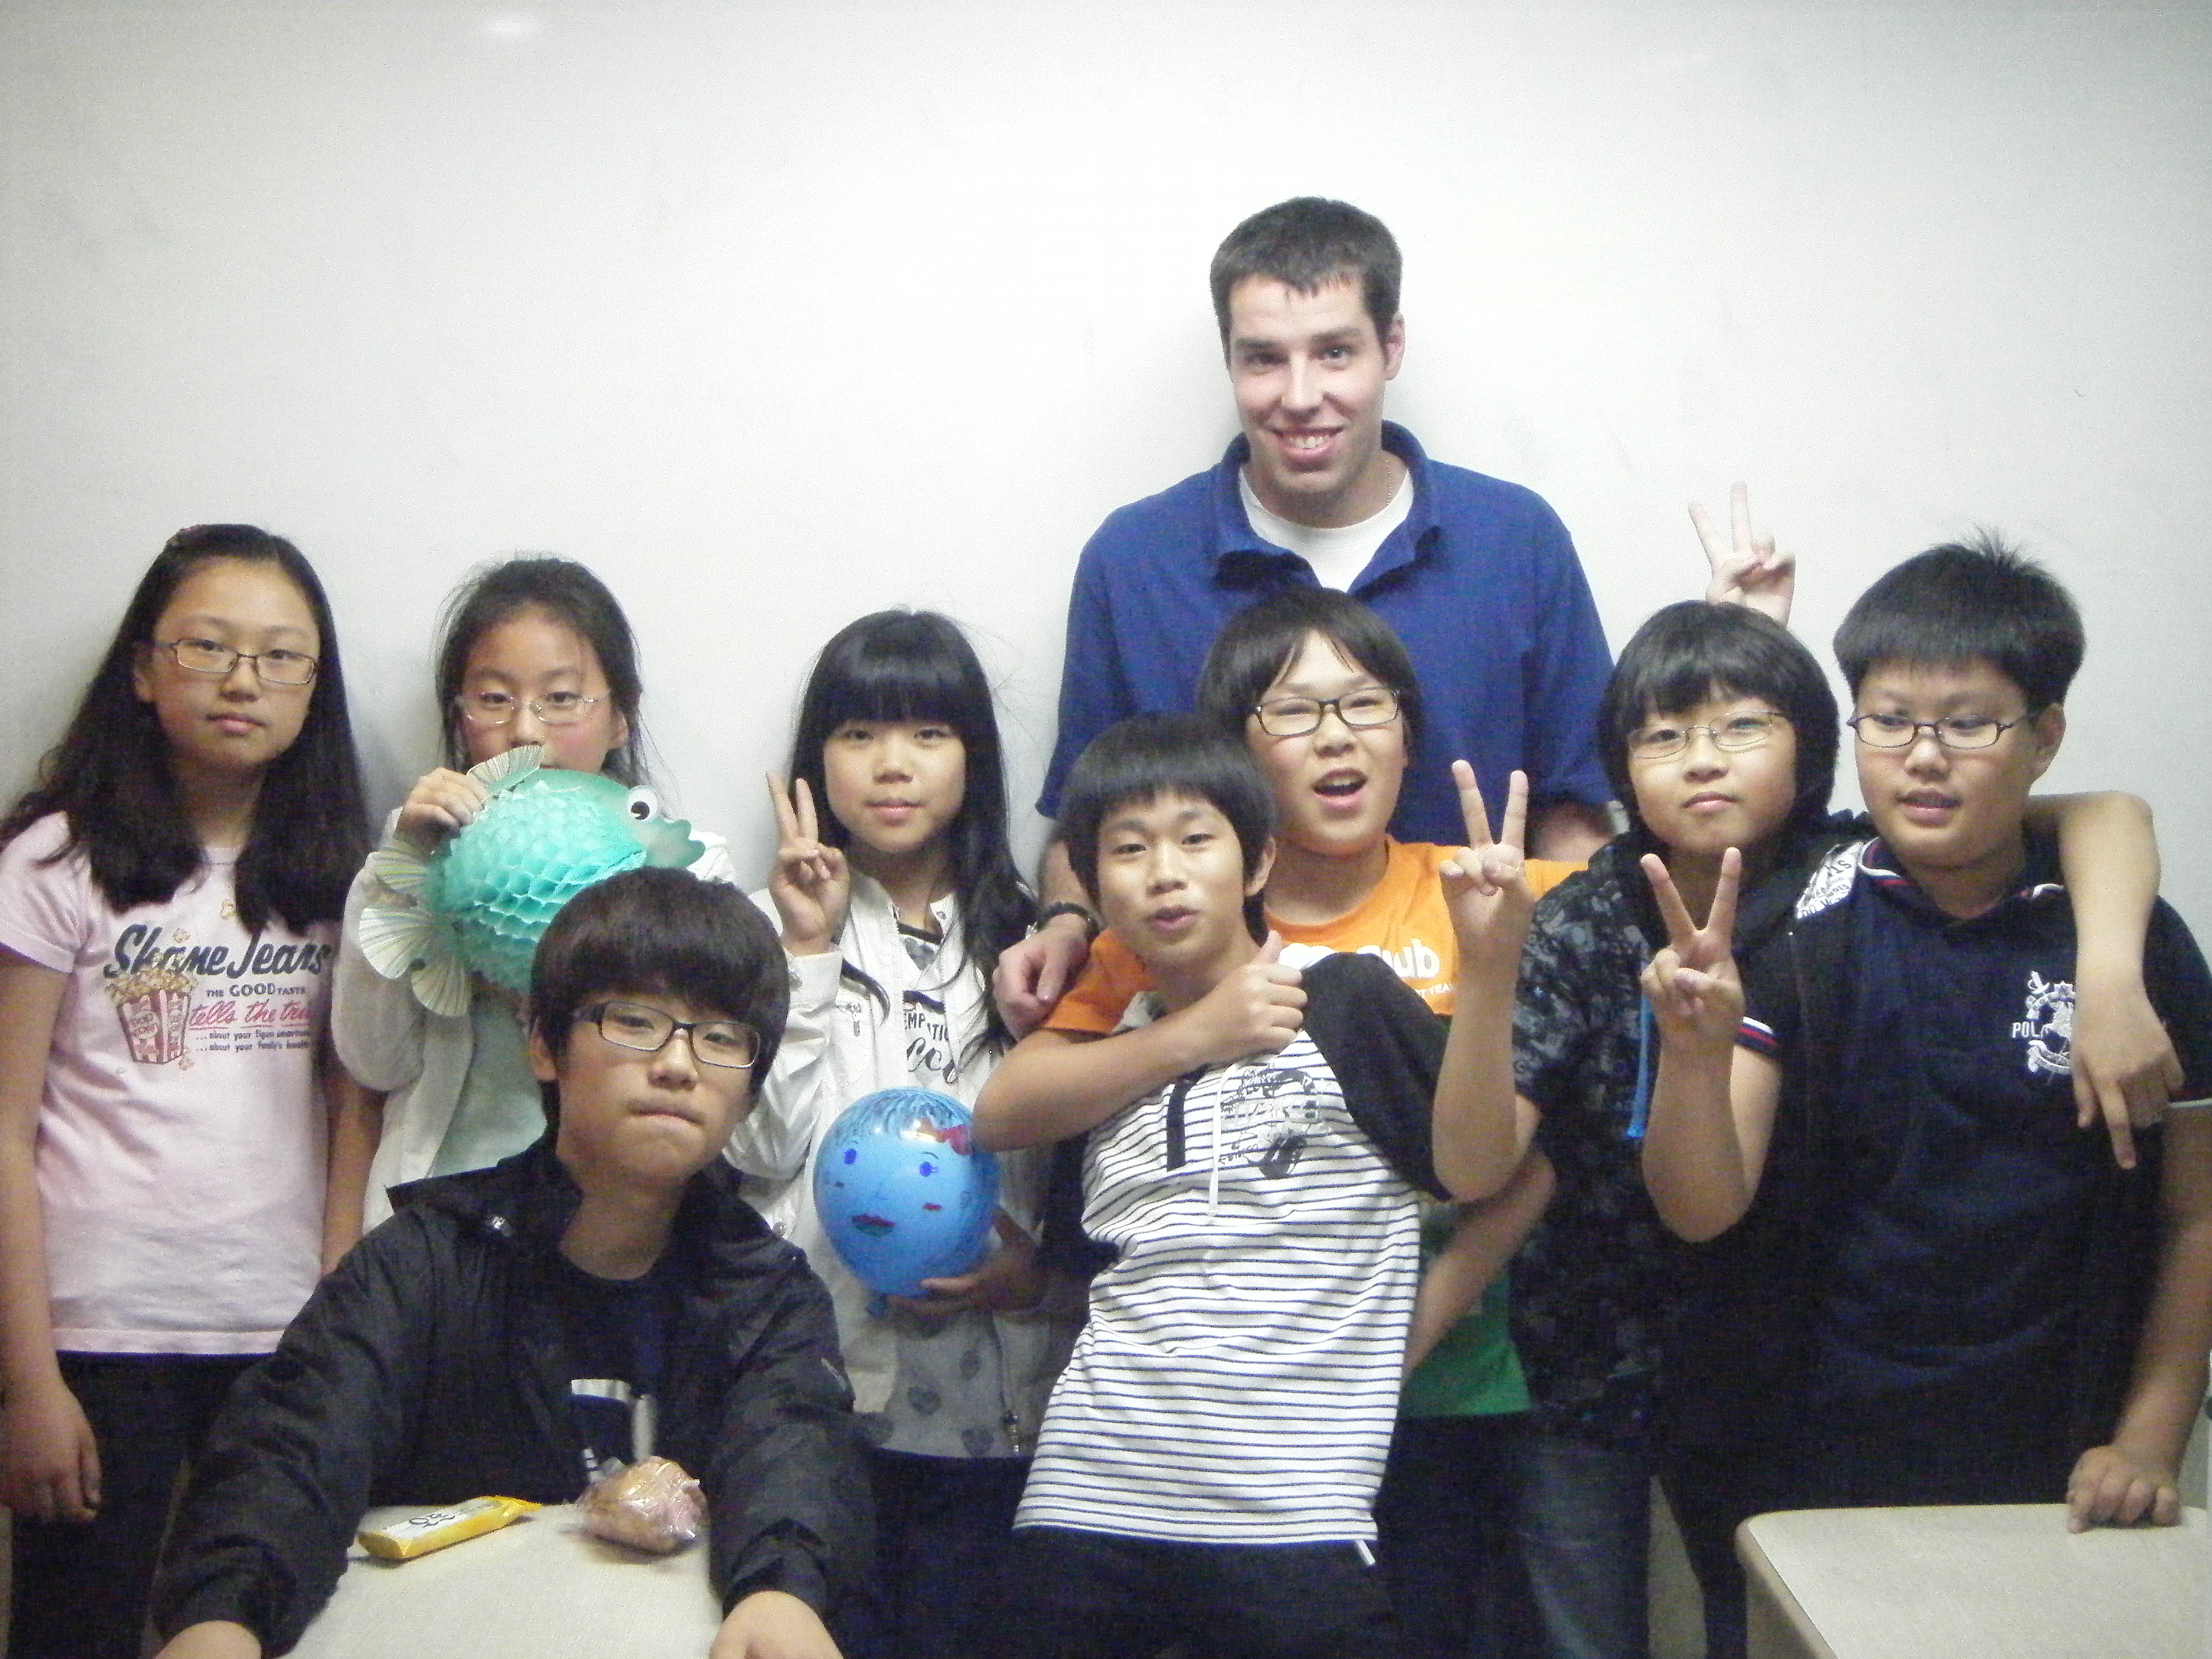
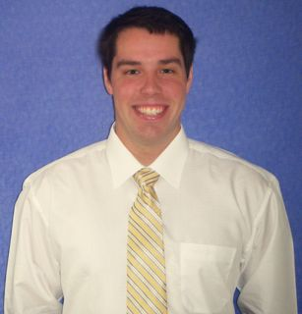
PERSONAL

Civil Status: Single

Date of Birth: 13 February, 1986
Nationality: U.S. citizen
Passport: U.S. Expires 11 February, 2017
Languages: English (Mother tongue), Spanish (Basic)

EDUCATION

Maximo Nivel S.A., San Jose, Costa Rica February 2009
TEFL/TESOL Certification
150 hours / Internationally Accredited Program / 6 hours
of practical teaching / 5 hours of observation.

Carroll College, Helena, MT, USA May 2008
Bachelors Degree: History / Minor in Biology
Member of PHI ALPHA THETA (National Historical
Honors Society)

PROFESSIONAL EXPERIENCE

Topia English Academy May 2009 – May 2010

English Teacher
- Taught 30 class hours/ week, plus a minimum of

5 hours/ week of class preparation
- Taught writing, listening, grammar, reading,

vocabulary and phonics
- Taught various skill levels from basic phonics

through advanced reading and writing
- Worked with students ages 8-13

Shodair Children’s Hospital 2008
Mental Health Technician
- Taught social skills to children ages 4-18
- Organized and ran physical activities for 20
patients
- Tutored patients with schoolwork
- Worked with doctors and therapists in adjusting
patients personal health plans
- Organized and ran group behavior interventions

Cowlitz County Title Summer 2007
Customer Service Assistant
- Talked with and collected orders from real-
estate agents, lawyers, banks, and private
contractors
- Researched deeds, property details, and land
history
- Created property information packages, and
foreclosure portfolios

United States Postal Service Summer 2004
Casual Carrier
- Delivered and collected mail and parcels
- Ran collection of drop boxes and scans

Monarch / Red Devil Hoop Camp Summer 2000 - 2003
Basketball counselor
- Taught children and teens basketball
fundamentals
- Mentored children and teens
- Helped organize and setup activities

Up Till Dawn (St. Jude’s Children’s Hospital Student 2008

Charity Group)

Volunteer
- Helped coordinate charity dinners
- Collected charitable donations from businesses
- Helped run children’s carnival activities
- Participated in sending out mailings for
donations

INTERNATIONAL EXPERIENCE

I have lived for a full year in South Korea. I have also lived and

studied in Costa Rica, and traveled in Central/South America

COMPUTER SKILLS

I am proficient in Windows, Microsoft Office, and Mac

programs. I also have experience using several grading programs.

REFERENCES

Sher Howell, Head TEFL Trainer, Maximo Nivel. S.A.
Tel: +50 6 2253 9220
Email: sherrybrouillard@hotmail.com

Dr. Robert R. Swartout, Jr., Professor and Chair, Department of History, Carroll College, Helena.
Tel: 1 406 447 4331
Email: bswartou@carroll.edu

Bill Bakamus, High school math teacher, varsity basketball coach, Mark Morris High School, Longview, WA
Email: bbakamus@longview.k12.wa.us

