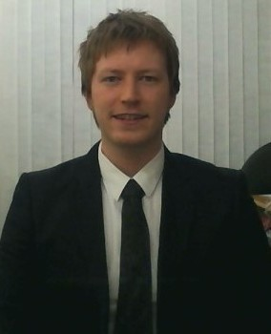

Martin Larkin

Basic Information

Mob: (+44) 7963173417
Email: martin.larkin@hotmail.com
Nationality: British
Place of birth: United Kingdom
Gender: Male
Languages: English (Fluent) French (Basic)

Personal Statement

As an enthusiastic and empathetic manager in my past profession, I can encourage and motivate people to achieve. A qualified EFL teacher, I enjoy being creative, and look forward to using my IT skills to create stimulating materials to inspire a class. I work well in a team and can communicate well with all levels and ages. Having researched teaching in South Korea I am enthused by the positive experiences TEFL teachers have. South Korea is a well-respected country in which to begin and continue a career, and I look forward to experiencing the rich culture and being involved with the communities I teach.

Education and Qualifications

140 hours Advanced TEFL Course including 20 hours classroom practical
I thoroughly enjoyed all aspects of this training and feel well-equipped to lead a class and help each student reach their full potential.
Language
- Grammar (Elementary, Pre-Intermediate, Intermediate)
- Lexis
- Phonology
Professional English
- Teaching one-to-one or groups
- Teaching Business English
- Teaching for specific purposes
- Teaching exam classes
Young Learners
- Behaviour Management
- Class routines
- Story telling with young learners

BA Classical Studies (2:2)
University of Manchester 2009 – 2012

A-Levels: English Literature (B) Classical Studies (B) Medieval History (B)
Wallington County Grammar School 2007 – 2009

Martin Larkin

Employment History

Trainee Manager
Home exposure, London, 2012 - 2013
- Coordinating a team of photographers
- Meeting potential clients, as well as existing clients
- Drawing / Coordinating floor plans to daily deadlines
- Organising galleries for clients within the company website

Creative Assistant (Part-time)
Imageconscious, London, 2011 – 2012
- Assistant photographer
- Drawing floor plans to meet daily deadlines
- Meeting clients on a daily basis

Assistant (Part-time)
Curtains Plus, London, 2009 – 2011
- Provide manual support to the track fitter
- Hanging and dressing curtains, blinds and pelmets
- Collecting and delivering fabrics, blinds and finished products from outworkers
- Cut fabrics, linings and interlinings to specific measurements

Extras

Voluntary:
I volunteered for two years (2008 – 2010) coaching a boys under-11’s football team on a Sunday morning. Through this highly rewarding role, I became confident in dealing with young children and their parents, as well as learning valuable skills in educating and motivation.

Technical:
Competent user of Microsoft Office, various bespoke software and Social Networking sites.

Travel:
I have travelled extensively during the past ten years and enjoy meeting new people and experiencing new cultures. My travels have taken me most recently to Australia and South-East Asia.

References available on request

