Nr 5 2 Pieke Flats
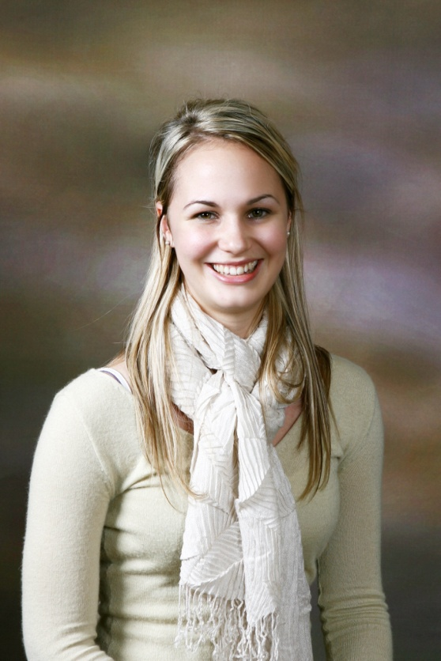
Martinson street
Stellenbosch
7600
Western Cape
South Africa
E-mail: conradie.marguerite@gmail.com
Telephone: (27) 076-466-9124 (South Africa)
(82) 010-7724-5073 (South Korea)

Marguerite Conradie
-Fond of a challenge
-Warm / Kind
-Good communicator
-Analytical
My name is Marguerite Conradie.
I’m 23 years old and am South African.
I have 2 years teaching ESL experience in Korea:
Age Groups: -Kindergarten and Elementary students (1 year)
-Elementary and Middle school students (1year)
I am interested in ESL teaching positions starting from September 2011!
I have Bachelors degree in Finance and graduated from Stellenbosch University in March 2009.
I would appreciate it if you would consider my application should any positions become available.
Feel free to contact me if you should need more information.
Kind Regards,
Marguerite Conradie

Resume
- Work Experience:
2010 – Present
ESL teacher to Elementary and Middle school students.
In addition to teaching conversation, my current position requires of me to help develop part of the curriculum and to make lesson plans, oral reports and conduct interviews for possible students. I believe this has helped me grow and become a better teacher.
2009 Kindergarten and Elementary school English teacher.
I taught English to Korean students at a private school in South Korea. (Korean Herald School)
I have teaching experience in grammar, phonics, creative writing, science and conversation.
2008 PSG Konsult Financial Planners
Worked in the Stellenbosch office for 2 weeks during the winter
break. (4th July - 18th July)
2007 Lanzerac Hotel and Spa
Worked in the hotel accounting department as a trainee for
1 month during December break.
2007 Financial Accounting Mentor
Involves working through accounting problems with a small group of first year accounting students who struggle with the course.
2005 Au Pair
Looked after a 15 month old boy in Canada as part of a gap year after completing high school.

2. Academic History
2006 - 2008
Stellenbosch University undergraduate.
BComm:
-Investment Management
-Accounting.
2004
Finished 5 year High school career in 3 years at age 16 years (87% average)
3. Skills obtained:
Language:
-English (fluent)
-Afrikaans (fluent)
-French - Intermediate reading, writing and speaking ability( 3 years tutoring as well as 1st year French at University Stellenbosch)
Computer:
-Microsoft Office
-Pastel Accounting partner (some experience)
4. Personal:
-Active management of my life and goals
-Responsibility – Acquired by having been responsible for someone else’s life (Au pair)
-Ability to adapt to different situations and foreign cultures.
-Solving problems from different angles by explaining them to my accounting group.
-Clear communication of concepts

5. Extra Curricular:
-Choir (member of the school choir for 8 years)
-Eisteddfod (Obtained various gold certificates for poems and prose)
- rock climbing
-Hiking
-Ceramics and Sketching (Art Grade 12, 2004)
-Ballet
-Modern Dance
References:
Please feel free e-mail or telephone me to enquire after references.

