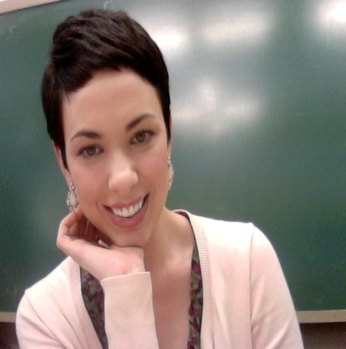

*Mallory Everhart

Experience
Volunteer Youth Counselor, YMCA, Conover, North Carolina
During my time as a counselor-in-training at my local YMCA, I learned how to manage and assist younger children when completing assigned tasks. I was in charge of arts and crafts with the 10-13 year olds; I love this opportunity because I was able to express my creativity while providing the children with an outlet to express themselves.

After-School Tutor, Hickory Hickory School, Hickory, North Carolina 2005-2007
As an after-school tutor at my high school, I assisted students with writing papers and understanding difficult coursework.

Team Leader, Style Exchange, Hickory, North Carolina 2006-2007
As a Team Leader, I managed approximately 9 other employees. I was the assistant to the owner and helped with the business aspect of the retail store. I created work schedules to accommodate each employees personal schedule.

Travel Assistant/Guide, Perquin Tours, Morazán, El Salvador Winter 2010-Winter 2011
As a tour guide with Perquin Tours, I guided journalists and tourist through former FMLN guerilla territory. I worked as an on-basis translator between the locals and tourists.

Mental Health Technician, River Park Hospital, Barboursville, West Virginia 2010-2012
During my employment with River Park Hospital, I managed and watched over approximately 10 patients in the hospital. I was in charge of creating and following through with their designated programs to assure their health and wellness.

Lifeguard, Beech Fork State Park, Barboursville, West Virginia Summer 2011
As a lifeguard at Beech Fork State Park, I completed a number of various duties within the state park. I worked as an office assistant, a park ranger, and also as a lifeguard. As a certified lifeguard, I am trained in CPR and American Red Cross Heart Saver First Aid.

Direct Support Staff, Autism Services Center, Huntington, West Virginia 2011-2012
Working as a member of the direct support staff at Autism Services Center, I manage three adults with autism and mental retardation. I am responsible for completing their daily rehabilitation programs and for assisting them in their daily activities.

English Teacher, Winner’s Academy, Daegu, South Korea 2012-2013
As a native teacher at a private English academy, I strived to teach English to native Korean students in the most enjoyable, fun way possible. I plan and prepare lesson plans based on individual needs and assessments. I keep record of students‘ progress, as well as, assist colleagues in keeping the learning atmosphere engaging and productive.

Education
Marshall University 2007-2012
Bachelors of Arts--Psychology

Extra-Curricular
Marshall University Anthropology Club
Marshall University Spanish Club
Marshall University Invisible Children
Huntington, West Virginia City Mission

Referrals
Letters of Reference available upon request.
Daniel Ball, Marshall University History Department (304) 654-3565
Patrick Forrestel, ESL Teacher for South Korea (010) 3515-7352
Marsel Deal, Conover YMCA Program Director (828) 446-3038

