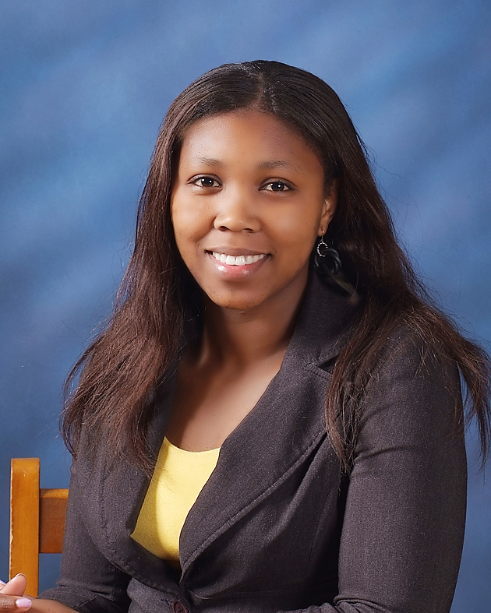

Akhona Qamngwana
Mapyeongdong 898 • Cheoin-gu Yongin • Kyeonggi • South Korea
Email: qamsakon@yahoo.com • Mobile/Cell: 010-7494-8985

Birthday • 09- 24- 1984
Marital Status • Single
Nationality • South African

Objectives

To Teach English as a second language.
To improve and practice my knowledge about language learning and teaching

Education

February 2005- March 2008
University of Western Cape, Western Cape, Cape Town, Bellville.
BA (undergraduate three years)
- Major in Language and Communications, Psychology, African languages

February 2010- Current
University of South Africa, Western Cape, Cape Town, Parow
BA Honors (4th year)
- Major in Applied Linguistics

Teaching Related Experience

October, 2008 – Current
Wonsam Middle School, English Teacher
• Teaching English grammar, speaking, reading and writing
• Regularly planning lessons and organizing English camps
• Researching and creating teaching resources/materials

Work Experience

November, 2007 – August, 2008
Tele-Tech South Africa, call center consultant
•Handling customer complaints
•Organizing Customer data
•Attending employee trainings for communication and other skills

Awards/Certificates Received

June 2011
• EBS Teacher Training Course (ETTC)

July 2009
•English Summer Camp certificate of Attendance

September 2008
• Teach English as a Second Language (TEFL)

July, 2008
•Accent and Conversational English (ACE)

Language Skills

• Native, English

Travel Experience

• South Korea, 3 years

References

Korean Co-teacher
Sin-song-Ah (Anna)
Wonsam Middle School
010-7285-0002

