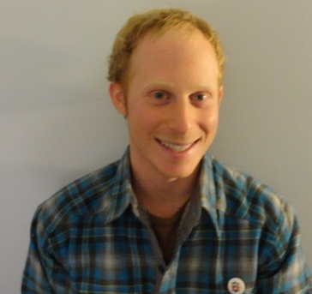
MICHAEL GERSTEIN
1001 Red Harvest Road
Gambrills, MD 21054 USA
(410) 672-6653
Mgerstein0@yahoo.com
OBJECTIVE:
To be part of a team teaching English to Korean students in Seoul.
WORK EXPERIENCE:
English teacher (contracted), EG language institute, Jeonju, South Korea 2011-2012
• Taught Korean students aged 8-14 (class size 1-14)
• Created lesson plans and assignments for:
◦ Essay writing
◦ Article and Novel reading
◦ Listening
◦ Grammar
• Created and graded assignments, tests, and term reports
• Worked with Microsoft Office to create easy to follow worksheets
• Administered and graded practice exams for standardized placement test (TOEFL)
• Participated in chaperoning field trips and organizing and running fun activities
• worked on a team of 11 teachers who shared duties
Animal Caretaker II, SoBran, Bethesda, MD USA 2008-2011
• Worked with various mammals in a clean laboratory environment
• Worked with foreigners who speak English as a second language
• Worked under a strict protocol
• Performed a variety of veterinary tasks
• Created spreadsheets and wrote professional style e-mails with scientists
CERTIFICATIONS
TEFL 100 hour certification 2013
EDUCATION
Frostburg State University, Frostburg, MD
B.S. Psychology Spring 2008
GPA: 3.29
Minor: Business Administration
HONORS
Psi Chi: national honor society in psychology Inducted Spring 2007
VOLUNTEER EXPERIENCE
WWOOF volunteer (Willing Workers On Organic Farms) New Zealand 2012
• Stayed with six hosts with varying garden environments
• Worked with foreigners who speak English as a second language
• worked on various duties for 4-8 hours a day, 7 days a week
• Performed a variety of garden tasks
◦ harvesting vegetables
◦ creating and maintaining garden beds with various soil types
◦ creating and laying various types of compost and worm farms
◦ maintaining small scale chicken coop
◦ many other hands-on tasks
REFERENCES
SunJin Lee: Academy Director of EG (Jeonju, South Korea)
Sullivansun@yahoo.co.kr
063-227-0579
Jocelyn Mckenzie: Farm host (New Zealand)
Jocelynoutram@hotmail.com
+640210469043
Greg Norfleet: Head teacher (England)
gregory.norfleet@spi.ox.ac.uk
+448799-827799
Daena Carrera: Facility Manager (America)
dccarrera@aol.com
+1240-417-4047

