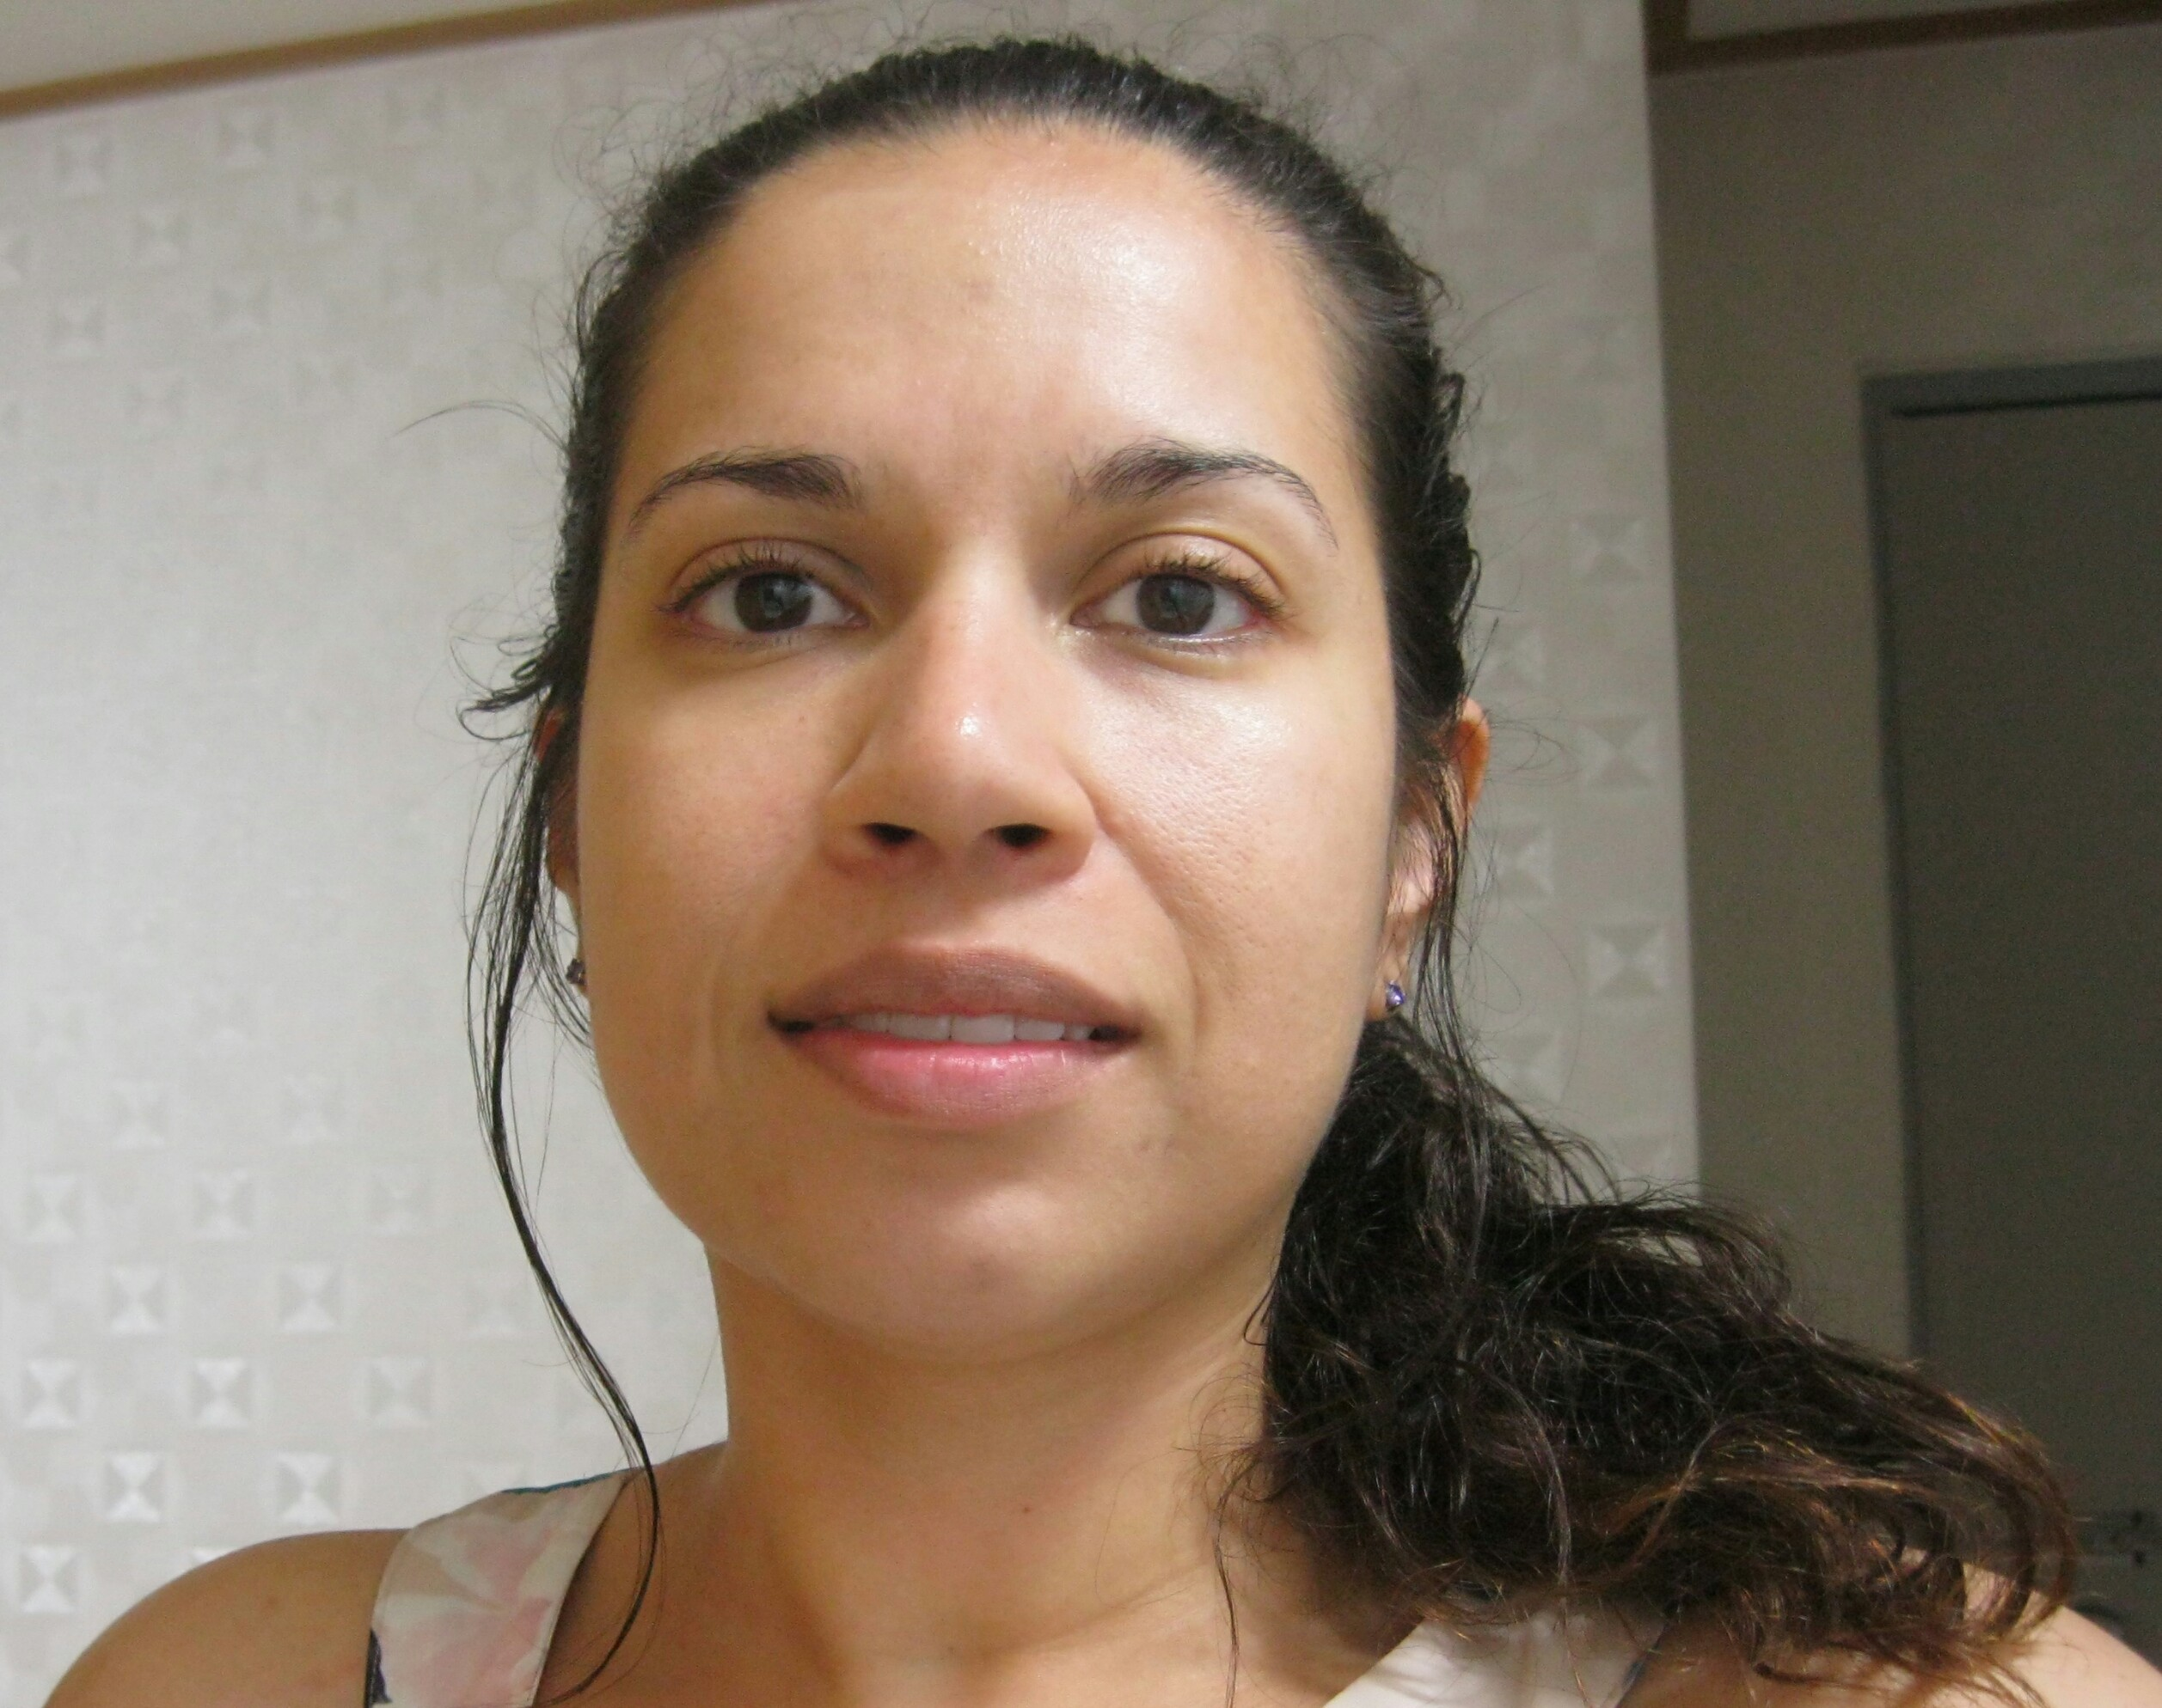
Stephanie A. Collado
Home (631)913-3901
Stephanie07@hotmail.com
Profile
Function well in high pressure situations and have a strong background in meeting deadlines. Creative thinker with strong customer service skills.
Languages- English, Spanish & Italian.
Education
M.B.A., C.W. Post Long Island University AACSB Accredited May 2007
The Princeton Review Says C.W. Post M.B.A. Program among Best in Nation
http://www.liunet.edu/cwis/cwp/pr/press/2007/171.html
B.A. Psychology, State University of New York at Stony Brook December 1999
The SBU Department of Psychology was founded in 1965. Members of the department have received awards for their excellence in teaching at university, state, and national levels. Many are nationally and internationally renowned researchers.
http://www.sunysb.edu/
http://www.psychology.stonybrook.edu/psychology/index.php?intro
Career History

NYLA Academy, Bucheon, South Korea
December 2012-February 2015

English Teacher
*All levels (kindergarten-Adult)
*Teaching 30 hours per week.
*Speaking emphasis

American City English/American International School/American City, Jukjeon, South Korea
January 2011-December 2012

English Teacher
*Kindergarten & Early Elementary
*Teaching 27 forty minute classes per week.
*Phone counseling weekly.

Avalon English Academy, Bucheon, South Korea
September 2010- September 2011

English Teacher
* Taught English to Elementary and Middle School children in South Korea
* Present learning materials to children of various fluency levels
* Lesson planning and creating educational supplements for class
* Taught 19 seventy minute classes per week
* Assisted Korean counterparts with understanding various concepts that were cultural and language oriented
*Teaching NEAT during intensives

Bilinguals Inc., Huntington Station, N.Y.
August 2004- December 2006

Billing Coordinator
* Helped department reduce payment rejection rates to almost 0%
* Consistently met monthly deadlines
* Established coordinated intra-department record keeping
* Audited paperwork and processed payment for over 210 independent
contractors during monthly two and a half weeks
* Created and signed off on vouchers billing the counties and the state
worth thousands of dollars each
InterCounty Appliance Corporation, Commack, N.Y.
May 2002-March 2004
Receiving Clerk
* Handled shipping manifest making sure all goods were accounted for
* Created and entered new model descriptions into the computer system
* Handled pricing calls from vendors requesting further information
* Managed inventory of products ensuring the warehouse and the
computer were in sync
* Input purchase orders for the most important accounts: GE, Maytag,
Whirlpool and Frigidaire/Electrolux
American Home Mortgage, Melville, N.Y.
December 2001-May 2002
Assistant to Director of Risk Management and Accounting
Department
* Helped with project to reduce fraudulent mortgage applications
* Helped with Mortgage Application audits by researching social security
numbers and their validity
* Assisted with meetings and conference calls with other offices across
the country
* Posted invoice payments and mortgage checks
Computer Skills: MS PowerPoint (presentations), MS Excel (Pivot Tables, Spreadsheets, formula calculations, charts). MS Outlook, MS Word, MS Access (macros), Lotus Notes, MS Windows, AS400 (inventory tracking), Solomon IV (check payment postings), CLAIMS (voucher building), Internet (research Lexis Nexis, Viewswire, OECD, IMF, Economist, IFS, WSJ, FT, NYT, Conference Board, BOJ, Business Source Premier)

