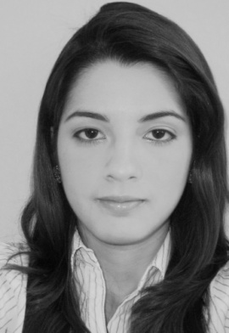
Mariangeli J. Miranda Martínez
December 21, 1988
AcroTower A-1310, Kwanyang-Dong,
Dongan-Gu, Anyang, Kyungki-Do Korea
(Mob)+82-10-5659-9449
(Tel) +82-31-478-9449
Nationality - Venezuelan
mariangelimiranda@hotmail.com

CARRER OBJECTIVE

To continue to deliver exceptional service to clients; ensuring a complete customer satisfaction while pursuing a win-win relationship between the client and the organisation. To use and further the organisational and negotiation skills already acquired to attain targets, achieve the organisation’s goals and ensure deadlines are met.

STUDIES
- Diploma In English For International Communication, 2008
Caribbean Learning Institute, Trinidad & Tobago, West Indies

- Diploma In English As A Foreign Language (TOEFL), 2007
ST. Kevin´s College LTD, Trinidad & Tobago, West Indies

- Completed the first year of degree in law, 2006-2007
Santa Inés University, Barinas- Venezuela

- Diploma in Science, 2002- 2006
“Don Cesar Acosta” High School, Barinas-Venezuela

WORK EXPERIENCE
- TIGER TANKS TRINIDAD UNLIMITED
Bilingual Receptionist
Labrea-Trinidad & Tobago, West Indies
February-August 2009

- GENESIS PHARMACY
Customer Services
Barinas-Venezuela
July-September 2006
KNOWLEDGE AND SKILLS
- Overseeing and performing routine work of areas as required, ensuring adherence to departmental and company procedures.
- Good Communication skills
- Good Time Management skills
- Self-starter willing to take initiative
- Leadership skills
- Good presentation skills
- Excellent communication interpersonal and negotiation skills

ADDITIONAL SKILLS
Languages:
- Spanish – Fluent (Native Language)
- English – Excellent
- Portuguese – Basic
- Currently Studying Korean

Computer:
- Windows XP, Windows Vista
- Microsoft Office, Internet

REFERENCES
- Available on Request

