CURRiculum vitaE: LORNA THOMAS

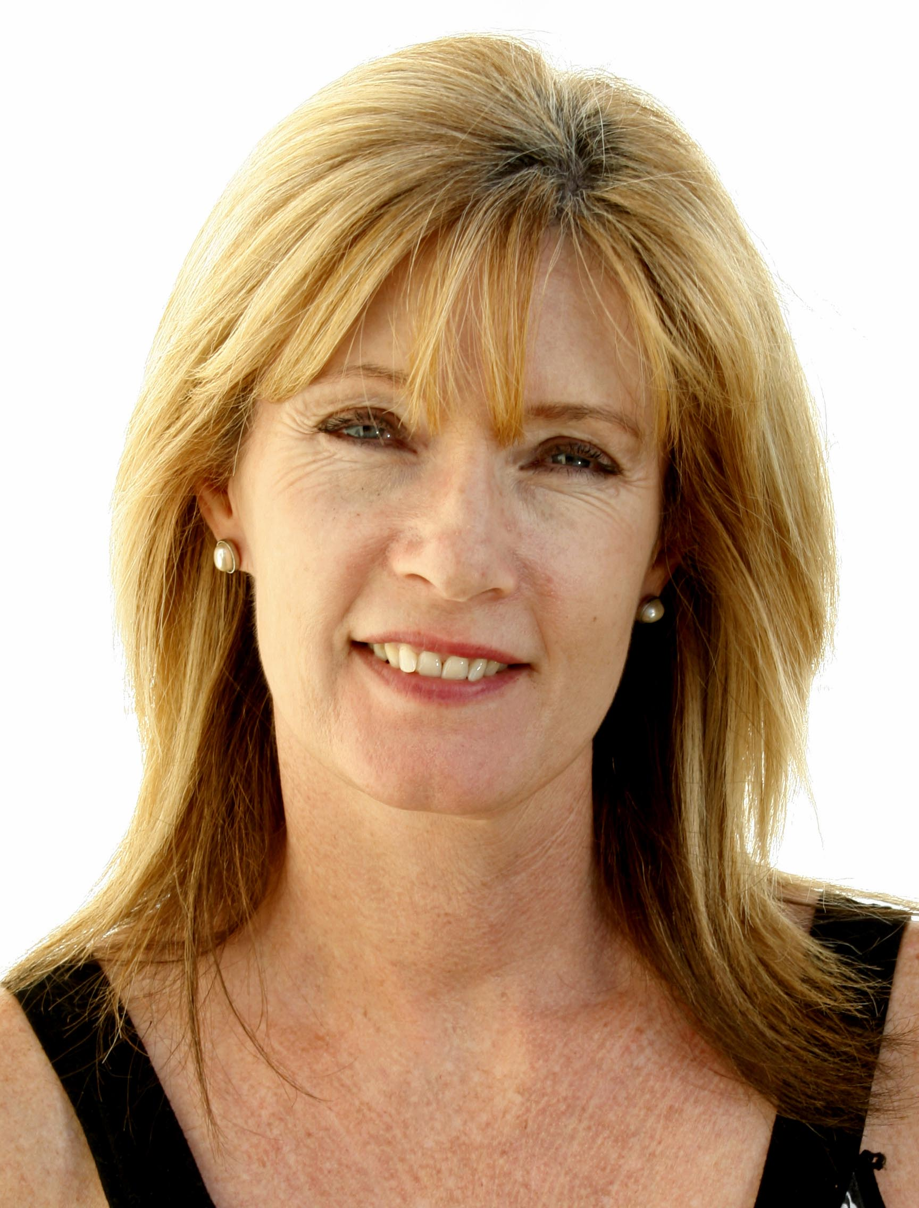

INTRODUCTION

I am a motivated, energetic and resourceful person who takes pride in everything I choose to do. I have enjoyed many successes in both my own businesses and the Companies I have worked for.
I am experienced in many areas, am able to cope well under pressure and to multi task accordingly. I am committed, enthusiastic, dedicated and have a strong work ethic with a willingness to work beyond the requisite number of hours.
I enjoy the creative nature of teaching where every day is different within a structure.
I am organized and a lateral thinker with creative problem solving skills. I have the ability to face challenges and to persevere when required.
I am a generally positive person and my interpersonal communication and relationship building skills are strong. I have an understanding of and love for young people and am very patient and flexible. I also have a good sense of humour and a high level of energy.
I enjoy working collaboratively; I am prepared to learn from others and enjoy sharing ideas with others to use in the classroom. I have a keen and ongoing interest in professional development and appreciate the transformative nature of teaching, both my students and my own. Teaching is a good fit for my interests and skills and I have developed a passion for it.
EDUCATION

University of Natal 1980 - 1985
Degree Social Science
Major in Social Work and Sociology

Various Professional Institutions 1986- 1998
Fitness and Personal Trainer

Lloyds TSB, UK 2003
Insurance Sales Training Program

Lotus Blinds (In-House) 2005
Art of Sales and Psychology of Sales

Boston House College 2006
Diploma – Interior Design

TEFL (140 hours) 2012
Cambridge English Teacher (currently completing an online Grammar course) 2013
AWARDS
Top Sales Person – Sh’zen 1990
Top Sales Person – Lotus Blinds 2007
Client Services Excellence – Lloyds TSB 2003

Membership of professional organizations
KOTESOL (Gangwan chapter) Professional development for ESL teachers.

professional eXPERIENCe
PRIME ENGLISH ACADEMY
Esl Teacher – November 2012 to present
I am the only conversational english teacher at the school and teach different ages and levels, from elementary to upper intermediate.
WOMAG
Sales Executive – February 2011 to October 2012
I was involved in sales of all the Company’s products, from tiles to marble and granite tops, etc. My clients include walk in retail customers, architects, designers, builders and project managers.
I left the company to start my teaching position in Korea.

BEE Verification Agency

National Sales Manager - July 2009 to January 2011

I was responsible for all national sales and marketing for the Company.
Apart from sales training I gave presentations on our product to potential clients (primarily engineers and architects)
I did primarily cold-calling or canvassing for new business and apart from telephoning clients I met with them to explain the verification process and promote the Company.

I left the Company for better prospects.

Matco Marketing

Regional Manager – 2008-June 2009
This Company supplies and manufactures industrial and specialized matting and I
performed the following functions for the Western Cape division:

Sales and Marketing.
Client relations: Existing customers and new business.
Management of Retail, Commercial, Industrial and Domestic customers.
Presentations to architects, project managers, designers, retailers, etc.

I left for better prospects.

Lotus Blinds & Flooring

New Business Sales Person – Client Services 2004 - 2007
I was responsible for calling on Clients in the Interior Design Market in the Western Cape as a sales person and relationship account manager.
My success was due to my high level of service excellence and relationship and communication skills.

I left the Company as a result of declining product quality and constant client complaints.

Lloyds TSB – UK

Client Services and Sales Consultant 2002 – 2003
I assisted clients with their insurance queries as well as inbound sales.

I left the company when I returned to South Africa.

Fabulous Frames – Western Cape

Retail Business Owner 1998 – 2001
I bought a small picture framing business in Tableview.
I managed all aspects of the business including staff, creditors and debtors, client services, factory and production.

I sold the business and moved to the UK.

Fitness Instructor – Own Business – Natal

Personal Fitness Instructor 1987 – 1997
After completing several fitness courses, I ran my own Fitness Instructor Business.
This included giving my own fitness classes, freelancing at various gyms and Personal Training of individual clients.

I stopped giving fitness instruction due to the demands of Fabulous Frames.

South African National Council for Drug & Alcohol Addiction (SANCA)

Social Worker 1985 - 1987
I worked as an intake worker in an outpatient treatment facility.

I left to work as a fitness instructor as my hours needed to be more flexible due to having young children.

Child and Family Welfare Society

Social Worker 1983 – 1985
I worked as an intern social worker specializing in Adoptions and Foster Care.
Skills

Computer Skills - Microsoft Word and Excel
Email and Internet

Management Skills - Personnel Management
Client Services
Organization, Co-ordination and Project Management

Life Skills - Relationship Building
Interpersonal Communications
Negotiation Skills

16/9/2013
To Whom It May Concern:

Hi
I am currently working as an ESL teacher at a hagwan in Donghae City, Gangwando, where I have been since 12/11/2012.
My contract expires on 12/11/2013 and I am looking for a new position in Seoul or surrounding areas from 25/11/2013.
I am enthusiastic and passionate about teaching and wish to continue to do so in the for-seeable future. I have taught students with varying levels of ability and ages (from Elementary to High School) and have enjoyed teaching all of them.
I am not satisfied with being just a good teacher who gets the job done and am striving to develop into an excellent one, who is prepared to go the extra mile.
I have a 140 hour TEFL qualification and am currently completing an online grammar course (Cambridge English Teacher) I hope to complete a CELTA qualification in the near future.

Kind regards

Lorna Thomas

