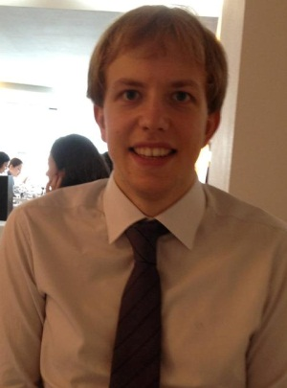
Laurence Mallows
(+82) 010-8050-6147 | lmallows@gmail.com

EXPERIENCE
2011 - 2012 Direct English Seoul, Korea
One of the largest 1:1 Hagwons in Korea
Native English Teacher, Jongno Branch
- Provided 1 hour one on one classes tailored to suit the student’s needs.
- Taught multiple class types including the DE program, Business English, job & MBA interview preparation and specialized classes for test preparation (IELTS & TOEFL), document review and accent training.
- Taught group conversation classes for 2-8 students for beginner to advanced students.
- Prepared lessons tailored to student’s needs, requests and level.
- Seconded to
2008-2011 myBoatshare.com Southampton, The United Kingdom
Membership sailing company.
- Ran online presence including; website, search and email marketing and customer bookings. Online marketing, including search optimization resulting in page one Google ranking on key search terms and pay per click advertising, online advertising was responsible for more than 40% of all sales leads
- Sales representative at several of the largest consumer exhibitions in the U.K.
2006-2007 Zurich Insurance Fareham, The United Kingdom
Global Insurance Company
Customer Services Representative & Administration assistant, Motor Insurance
- Customer Service Representative: Handled inbound sales and service calls from customers
- Administration Assistant; processed and dispatched legal and sales documents to customers and affiliate companies
EDUCATION
2007-2011 Keele University Keele, The United Kingdom
Upper Second Dual Honours B.A. (Hons) Politics and International Relations.
- Elected Faculty Representative 2010 & 2011; representing student views at a Faculty level, organizing events and assisting new students
- Awarded life time membership to the student union in recognition of outstanding contribution to academic life and student services.
- Communications Officer for Keele Model United Nations; increased new member recruitment and retention by more than 50%, attended multiple international conferences, winning awards at most.
- Delivered public speaking seminars for new members, helping to create the society’s most successful ever conference delegation.
ADDITIONAL
Qualifications • 2011: 120 Hour TEFL Certificate, i to i, London. 100 hour combined online and classroom course, 20 hour online grammar course
• Clean full UK driving license

Interests • Avid sailor with Day Skipper certification, participated in three Round the Island races as well as various casual voyages. Squash player and chess enthusiast with a strong interest in world affairs.

References available on Request

