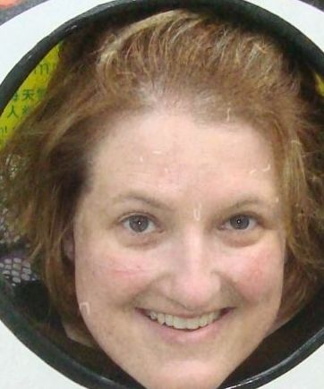

Laura Sadowski

Professional Experience
CNA/CMA August 2009 - December 2012
- Administer medications or treatments, such as catheterizations, suppositories, irrigations, enemas, massages, or douches, as directed by a physician or nurse.
- Answer patient call signals, signal lights, bells, or intercom systems to determine patients' needs.
- Apply clean dressings, slings, stockings, or support bandages, under direction of nurse or physician.
- Communicate with patients to ascertain feelings or need for assistance or social and emotional support.
- Document or otherwise report observations of patient behavior, complaints, or physical symptoms to nurses.
- Feed patients or assist patients to eat or drink.
- Provide physical support to assist patients to perform daily living activities, such as getting out of bed, bathing, dressing, using the toilet, and standing, walking, or exercising.
- Record vital signs, such as temperature, blood pressure, pulse, or respiration rate, as directed by medical or nursing staff.
English First Language School Daqing Heilongjiang China
ESL Teacher May 2008 - April 2009
- Initiate, facilitate, and moderate classroom discussions.
- Evaluate and grade students' class work, assignments, and papers.
- Prepare course materials such as syllabi, homework assignments, and handouts.
- Teach writing classes.
- Maintain student attendance records, grades, and other required records.
- Plan, evaluate, and revise curricula, course content, course materials, and methods of instruction.
- Keep abreast of developments in the field by reading current literature, talking with colleagues, and participating in professional conferences.
- Assist students who need extra help with their coursework outside of class.
- Maintain regularly scheduled office hours to advise and assist students.
- Compile, administer, and grade examinations, or assign this work to others.
- Collaborate with colleagues to address teaching and research issues.
- Participate in cultural and literary activities, such as traveling abroad and attending performing arts events.
- Participate in student recruitment, registration, and placement activities.
ESL Teacher June 2005 - January 2006
- Left Daqing EF to care for family member going through chemotherapy.
Future English School Benxi Liaoning China
ESL Teacher May 2003 - December 2004
- Collaborate with other teachers or administrators to develop, evaluate, or revise kindergarten or elementary school programs.
- Confer with other staff members to plan or schedule lessons promoting learning, following approved curricula.
- Establish and communicate clear objectives for all lessons, units, and projects to students.
- Establish and enforce rules for behavior and procedures for maintaining order among students.
- Signed six month contract.

Education
Bethel College North Newton Kansas United States
Social Work, December 2012 (Bachelor’s Degree)
- Gaining a heightened awareness of the social inequality and social justice issues that are often behind personal issues and problems. Personal and family problems frequently reflect larger public issues – ways to identify and begin to remedy those issues. Social work rests on the liberal arts as a foundation for understanding humans in the context of their social, cultural and economic environment. The liberal arts also helped develop skills necessary to be an effective professional social worker: oral and written communication skills as well as the ability to think analytically and synthesize information from a variety of sources. Practicum placement within a hospital and nursing home.
Hutchinson Community College Newton Kansas United States
Education, May 2008 (Associate Degree)
- An academic degree conferred by the two-year college after the prescribed course of study had been successfully completed. High GPA, reached placement on Dean's List.
Berean Academy Elbing Kansas United States
High School, June 1992 (High School Diploma)

Additional Skills
- I was a pre-school teacher from 2001-2003 in Newton, Kansas.
- I have completed the ESOL examination for the TKT: Young Learners from the University of Cambridge with a Band 3 (out of 4).
- I also completed the 40 TEFL certificate with an ‘A’.
References and verification can be presented upon request.

