RESUME
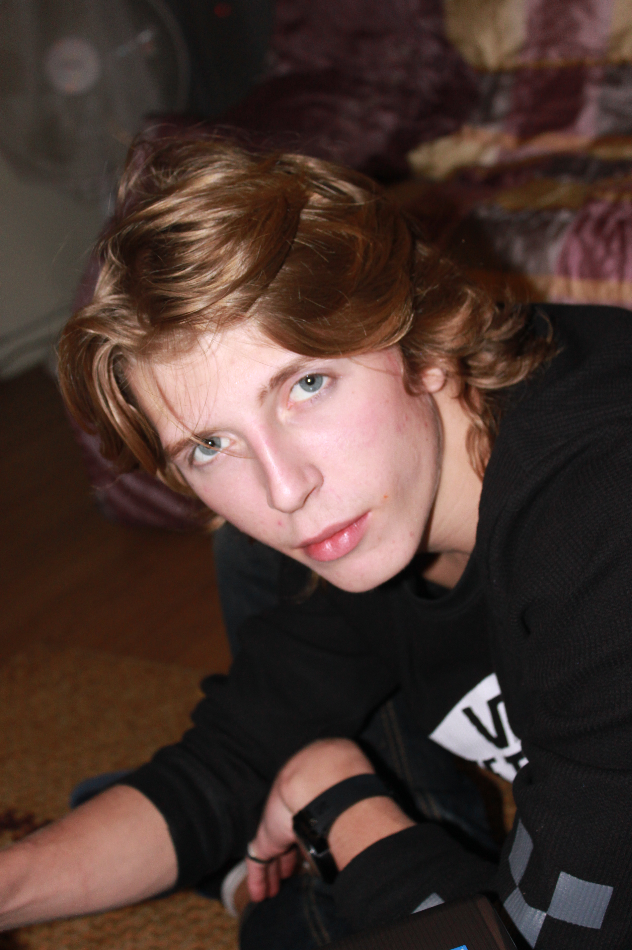 |  | Name in full |  |  |  | Lance-T Demidov
 |  | Date of Birth |  |  |  | January 25, 1990
 |  | Residence |  |  |  | SongpaGu Pang-I-2 Dong 49-5  Olympic Park Zone Suite 304  138-828  Seoul, Korea
 |  | Phone # |  |  |  | 010-7432-8230
Education  2001  2005  2009  *** |  |  |  |  | Graduated from F.A.C.E Elementary school  Quebec , Canada  Graduated from Loyola High School  Quebec, Canada  Graduated from Santa Monica College  Degree in Arts and Choreography  Santa Monica, California  Studied Tattoo Art, Design , after school art lessons
Experience  2009 |  |  |  | - Worked as a private tutor for students going abroad ages ranging  - from 5-12  - Am currently working as a part-time instructor for SaRang  - kindergarten in Dongdaemun (ages 5-7)  - Model for Ads and Commercials (I Pad, clothing, and runway)  - Working part time as an assistant instructor at Talking Club
Available working hours | Part time Monday-Friday (Saturdays and Sundays are negotiable)

I hereby declare that the above information is in every respect true and correct to the best of my knowledge.

Lance Demidov

December 2010

I am a passionate instructor who understands students and is compassionate to their needs. I understand how tough it is to learn a second language due to the fact that I come from a multi ethnic background( Canadian/French/Polish) and I have hands on experience teaching children who are learning English for the first time. I am good with children and they seem to like me too. I am very active and hard working. I believe that I have a lot of skills that are innovative and useful for students who are learning English. I have a background in art and choreography so I have skills to teach English through the arts as well as academically. If you are looking for someone who is punctual, energetic and hard working please give me a call at 010-7432-8230. Thank you.

