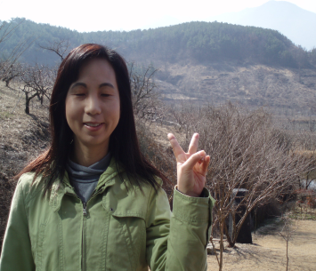 | Kay Chang  e-mail: k2chang_2000@yahoo.com  C.P.: 010-3106-0064 | 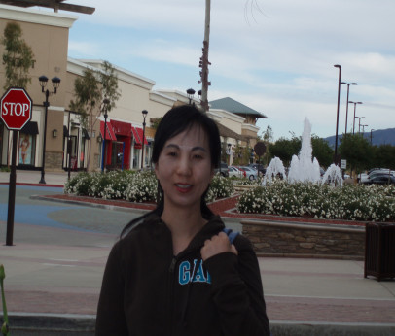

Hanyang-Oregon TESOL Certificate
University of California, San Diego: Psychology (B.S.)
Salamanca, Spain: Study Abroad
Citrus College: Child Development

As a Native English Teacher:
TOPIA & Canada International School in Ansan (May 2011 ~ Feb. 2012)
Gusung Middle School in Yongin: (May 2010 ~ May 2011)
Songwoon Elementary School in Siheung: (May 2007 ~ May 2010)

[afterschool program]
Kwangduk Middle School in Ansan [Language Arts]
Songwoon Elementary School: 3rd & 4th grade [Language Arts, math, science, art]
Songwoon Elementary School: 1st & 2nd grade [Language Arts, math, music, art]
Songwoon afterschool program: 6th grade [Language Arts]

[English Festival]
Participated Siheung English Festival as an English Speech Contest Juror (2008)
Award: 경기도 교육장 표창장 수상 (2008)

[Other Part-Time Teaching Experiences—grade school students]
I have experienced teaching at few private institutions: 정철어학원, 이보영 Talking Club, 쎄스어학원 for reading, writing, speaking, listening, grammar, daily conversations, TOEFL, and debate.

