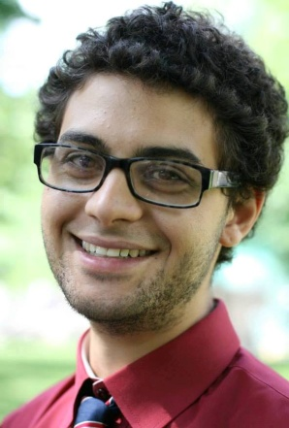
Joseph Tessy

Education

2009-2013 McGill University, Montréal, Canada,
Major: Political Science
Double Minor: International Development and Music Technology
2006-2009 Seoul Foreign School, Seoul, Korea – High School Diploma (Honors Student)

Work Experience

Assistant Trade Commissioner
Consulate General of Canada in Boston, Full Time: Summer 2013
- Worked on Canadian Technology Accelerator in Cambridge Innovation Center
- Focus on Trade Commissioner Services in Trade and Commercial Sector of Consulate

McGill University Financial Services, August 2012 – April 2013
Work Study employee
- Student Accounts administrator: setup new database management system
- ID clerk at McGill Service point: assisted with orientation for new students

DHL warehouse employee, Full time: Summer 2012
Franklin, Massachusetts
- Rotated through multiple assignments covering all facets of warehouse operations including mail receiving, encoding, and sorting.
- Worked in both Spanish and English

Theatre Maintenance Work, Summer 2011
Seoul Foreign School, South Korea
- Worked for Darrell Roddick, Director of Performing arts at SFS
- Responsible for building, taking down, and painting sets for successful theatre and music productions

English Teacher, Summer 2010
Mentor Plus English Communication Hagwon
- Private English tutor for children aged 9 – 15
- Fostered an enthusiastic atmosphere for ESL development through developing creative writing, critical thinking, and English grammar skills

Summer Intern, Summer 2009
Canadian Chamber of Commerce in Korea
- Assisted with preparations for Canada Day Celebration
- Set Up Chamber directory database to enhance efficiency and external communications of Chamber operations

Private Guitar Tutor, 2008 – 2010
- Private guitar tutor to International school students in Korea

