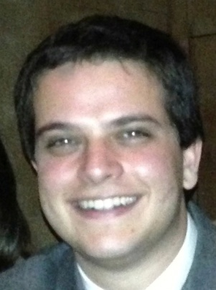

Joseph Pasik

EDUCATION
New York University, College of Arts and Science, Undergraduate Program
20092013 — Major in psychology, minor in business studies

The Bronx High School of Science
20052009

RESEARCH EXPERIENCE
Anthropological Field Study on Hospital Technicians
February March 2011 — Extensive three month field study and written report to better understand the life of hospital technicians and what it means to be part of their community.

Participation in Intel Research Competition
20082009 — “The Link Between Clinical Depression and Platelet Adhesion and Aggregation in Patients with Stable Coronary Artery Disease”. Mentor: Juan Badimon M.D. Ph.D, Mount Sinai School of Medicine

WORK EXPERIENCE
NetSuite
Summer 2012 — Sales Intern

The Boy’s Club of New York
Spring 2012 — Taught an SAT preparatory course

CREOpoint
Summer 2011 — CREOpoint is a company that provides exclusive social networking for commercial real estate professionals. Analyzed www.CREOpoint.com for both design and usage patterns, delivered report for improving the website to encourage more traffic and better member adoption rates.

Robbins Wolfe Eventeurs
Summer 2011 — Catering
Stuart’s Fish Market
Summer 2010, 2011 — Retail and food preparation

Raw Media Network
Summer 2006 — Video production

OTHER
SPSS proficient

Master Scuba Diver
Certifications in open water, advanced open water, rescue, night dive specialization, nitrox certification, AWARE fish identification, buoyancy control, kayak specialization

