Curriculum Vitae

Personal Details:
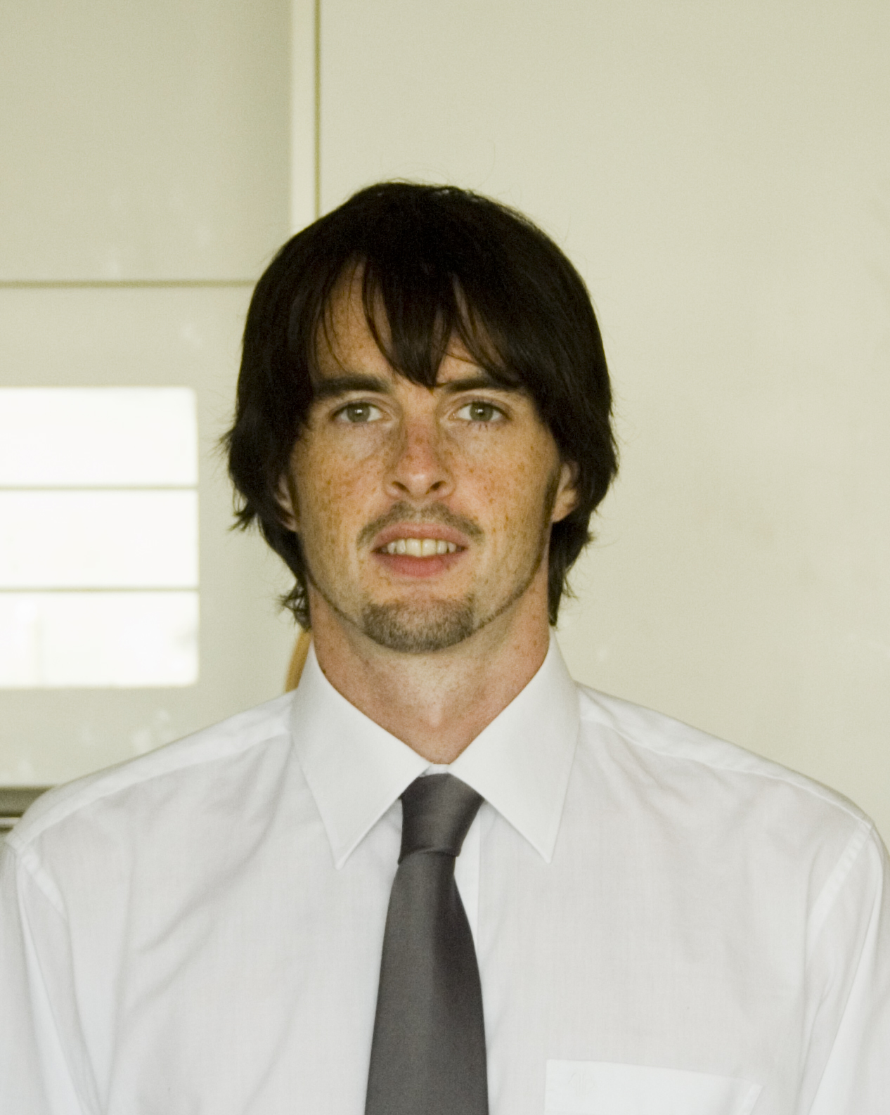
Name: John Patrick Hickey

Date of Birth: 20-05-1977

Nationality: Irish citizen

Passport: Republic of Ireland, valid until 22-05-2019

Email: rezbot@gmail.com

Phone Number: (010)-8746-9488

Career Summary:
2007 – 2009 ● Instructional/Media Designer, Hibernia College.
● Webmaster, Harvard University Club of Ireland, www.harvardclubireland.com
● Freelance Web Designer/Developer.

2007 English Teacher, LCI Kid’s Club Hagwon, Sinpyeong, Busan.

2006 – 2007 English Teacher, ECC Hagwon, Jangyu, Gimhae.

2005 – 2006 Travel.
2003 – 2005 Senior Graphic Designer, Hibernia College.

2001 – 2003 Freelance Web Designer/Developer/Graphic Designer.

2001 – 2002 Part Time Web Designer/Developer, Dun Laoghaire Institute of Art, Design & Technology.

2000 – 2002 Graphic/Web Designer, Paragon Design.

Education/Training Summary:
2006: TEFL Certificate, Text & Talk Academy, Chiang Mai, Thailand.
120 hour intensive course over six weeks.

1999 – 2000: Bachelor of Design, Dun Laoghaire Institute of Art, Design & Technology, Dublin, Ireland.

1997 – 1999: Diploma of Design, Dun Laoghaire Institute of Art, Design & Technology, Dublin, Ireland.

1995 – 1996: National Certificate in Art & Design, Dundrum College, Dublin, Ireland.

1989 – 1995: National Leaving Certificate, Rockbrook Park Boys School, Dublin, Ireland.

Teaching/Training Experience:

2006 – 2007 ECC, Jangyu
English teacher at ECC Hagwon, Jangyu, Gimhae City. During my twelve month contract at ECC I taught conversational English to students ranging from elementary school level, through to middle school and high school level. My working week was from 12.30pm – 8.30pm, Monday to Friday, consisting of six fifty minute classes per day. During summer break my day began at 11.30 am with the addition of two extra junior elementary classes. My teaching day generally followed the curriculum set by the YBM ECC program however certain classes required that I bring my own content, direction and ideas into the classroom.

LCI Kid’s Club, Sinpyeong
On completion of my twelve months at ECC I took up a two month temporary position at LCI Kids Club Hagwon, Simpyeong, Busan. My working week at Kids Club was from 10.00am until 4.30pm or 7.00pm depending on the day. I taught English to students ranging from Kindergarten level through to elementary school level and middle school level. During my time teaching I was required to follow the Kids Club curriculum which included conversational, reading, and writing programs. I also taught several science classes during my time there.

2006 TEFL, Thailand
While training as TEFL teacher I gave classes to Thai nationals at beginner and intermediate level. The students ranged in age from 8 to 35+ years. The classes were up to twelve students in total and students within these classes had different abilities with their level of English.

2003 – 2005 Graphic Designer of educational content
Graphic Designer at Hibernia College. Hibernia College is Ireland's nationally accredited third level online College, offering flexible web-enabled learning opportunities to students and organisations in Ireland and internationally.

In this role I was directly responsible for the design and presentation of many online
Degree and Masters Courses. I would liaise with the course academic author and design/develop their course modules into illustrated internet educational material. When complete I would make the material available to the students to study as the core part of their four year program.

An important part of my role was training large groups of new students in the use of the special software necessary to study their online program. Many of these students were Irish National School teachers who were undertaking a four year government accredited degree course.

The two hour training would take place in a lecture hall or classroom where I would instruct up to 25 professional teachers with the aid of a PowerPoint or Flash presentation. I would also give similar instruction and support to groups of students at online virtual classrooms using special group communication software.

The college homepage is: www.hiberniacollege.net

1999 – 2000 I have given training on the use of photographic equipment & software packages to groups and individual students at Dun Laoghaire College of Art.

Other: ● Irish (EU) Drivers License.

● International Driving Permit.

References: ● Mrs. Ann Yoon – Director, YBM ECC Academy, Jangyu, Gimhae, South Korea.

● Mrs. Lee - Director, LCI Kids Club, Sinpyeong, Busan, South Korea.

● Dr. Sean Rowland - President, Harvard Club of Ireland.

● Dr. Nicholas Breakwell - Chief Knowledge Officer, Hibernia College, Ireland.

References available on request.

Availability: I am currently available for employment.

