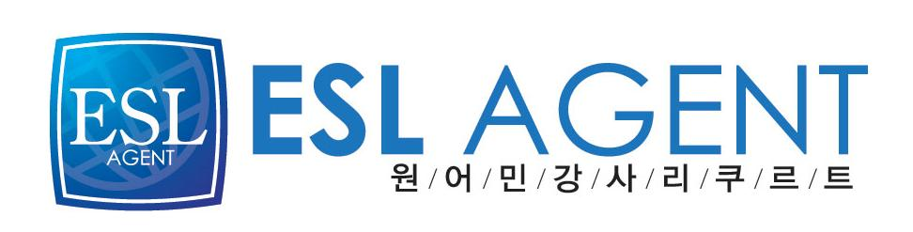이에스엘 에이전트
박우경(Rosa)
02-2675-0582
010-4518-1571

John Cantzon Foster

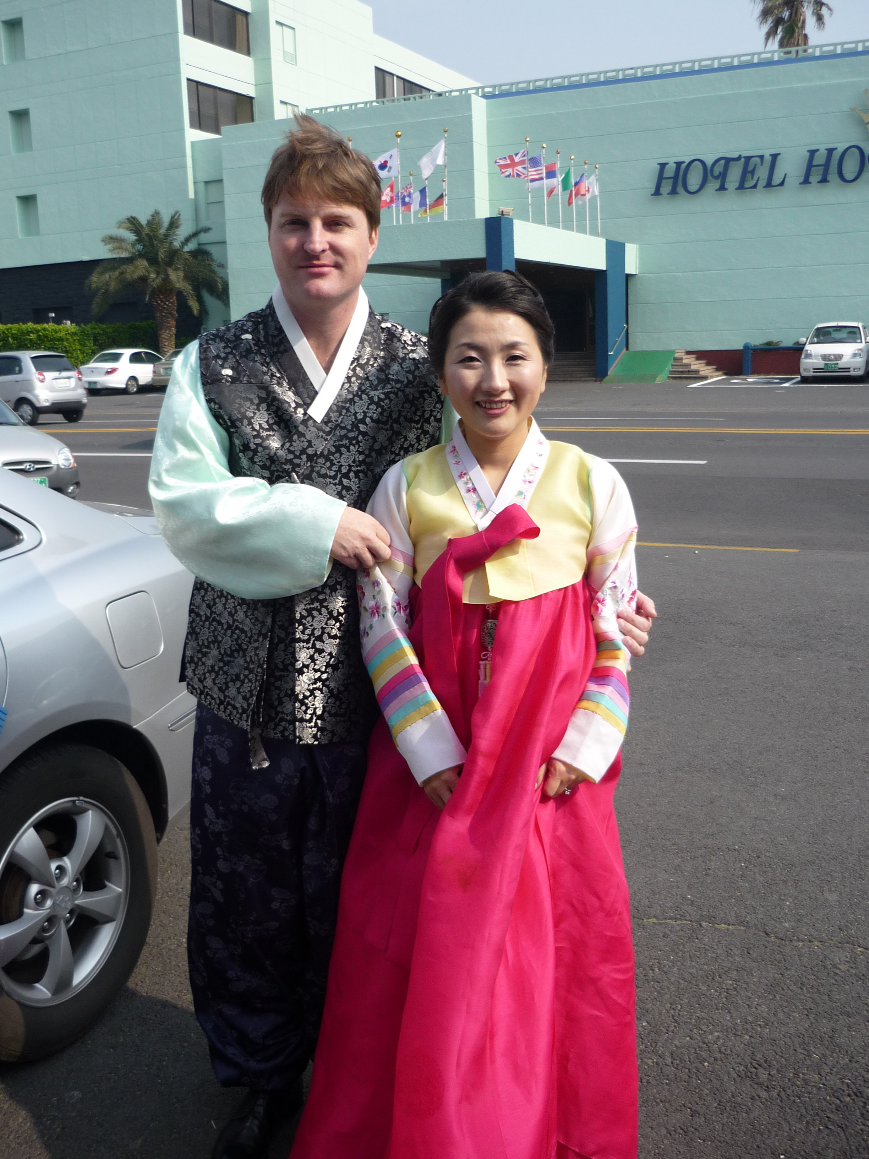
1144 Marsh Harbor Lane
Charleston, South Carolina 29492
phone: 843-870-8790
email: cantzon@gmail.com
Education:
Bachelor of Arts in Media Arts, May 1992
The University of South Carolina, Columbia, SC, USA
Avid Editing, December 2000
Digital Systems Incorporated, Atlanta, GA
i-to-i TEFL Teaching Certification, September 2004
Professional Experience:
5/07-12/12
Kindergarten, Elementary and High School Teacher, EPIK Program, Jeju Do
Pyungdae Elementary School ESL Instructor
Dori Elementary School ESL Instructor
Hallim Technical Institute ESL Instructor
Daehul Elementary School ESL Instructor
Hallim High School ESL Instructor
Aewol High School ESL Instructor
Halla Elementary School
Kindergarten and Elementary School Teacher, Bambini English Institute
3/06-3/07
Kindergarten and Elementary School Teacher, Bambini English Institute
Yeondong 1371-3 Sewha Building 4F, Jeju City, South Korea 690-817
064-711-8777
3/05-1/06
Kindergarten and Elementary School Teacher, Jeju Wonderland,
Sam Samdashinhyup Samdo 2 dong, Jeju City, Jeju Do, South Korea
10/99-1/04
Retail Sales Manager, Star Music Company,
Columbia, SC, USA
Primary purchaser for three store locations.
Responsible for hiring and training new employees.
Handled shipping and billing for all locations.
Coordinated repair services for stringed instruments.
10/89-9/03
Private Music Instructor
Taught acoustic, electric, and classical guitar
7/92-9/94
Media Resources Coordinator
Low Country AHEC, Hampton, SC
Coordinated distance learning systems for allied health care providers.
Developed physician recruitment videos for rural based health care providers.
Managed media resources for hospitals throughout the low country, SC.
Successfully recruited physicians to work at the Harrison Peeple’s Health Care Center
Internship:
South Carolina Special Olympics, Charleston, SC, USA
Tree of Life Synagogue, Columbia, SC, USA

