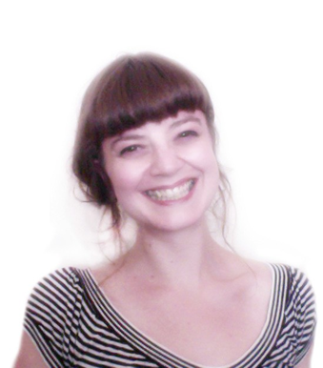
Jennifer Prevatt
5399 Ortega Bluff Lane
Jacksonville, Florida
32244
USA

Date of Birth: June 11th 1982
Nationality: USA

Objective
Seeking a position as an ESL teacher that will allow me to utilize my creative
background as an effective teaching tool

Highly enthusiastic, positive, and self motivated with a strong work ethic

Demonstrated ability to develop rapport with people of various cultures and ages

Managerial and service industry experience

Working knowledge of Adobe Photoshop, Illustrator, InDesign, AfterEffects, and Corel Painter X, HTML, and CSS

18 months teaching experience in Incheon, South Korea

MFA, BA, and AAS degree holder

Completion of Introduction to Teaching & Learning in Higher Education (ITLHE) workshop

Years of experience organizing educational events for children

Excellent communication skills and ability to work independently or with a team

Study Abroad Courses
July 2013: Creating a Context, Artist-in-Residence
Erasmus Intensive Program
Duisburg, Germany

May 2009:
Botanical Illustration Course
Margaret Mee Foundation
Manaus Amazonas, Brazil

June - July 2008:
Intensive Italian Immersion Program
Umbra Institute
Perugia, Italy

2012-2014:
Master of Fine Art Newcastle University
Newcastle upon Tyne, UK
Ma jor: Fine Art

2007-2010:
Bachelor of Arts
Arcadia University
Philadelphia, Pennsylvania, USA
Ma jor: Scientific Illustration
Minor: Italian

Honors: Phi Beta Delta, departmental honors
Awards: Grant Newcombe Endowed Scholarship, Distinguished Scholarship

2004-2007:
Associates in Applied Sciences
Borough of Manhattan Community College
New York, New York. USA
Ma jor: Multimedia Art

Honors: Phi Theta Kappa
Awards: Multimedia Art & Design Award in the Department of Cooperative Education, Academic Excellence in Multimedia Art & Design in the Department of Music & Art

December 2011 – May 2012:
Cony Evans
Incheon, South Korea
English Instructor
Taught conversation English to
adults at a basic, intermediate, and advanced level using prepared lesson plans; Taught conversation English to elementary, middle, and high school students; Conducted activities with children that focused on grammar, pronunciation, and vocabulary building skills

December 2010 – November 2011:
Kafec Language Academy
Incheon, South Korea
English Instructor
Taught conversation English to elementary, middle, and high school students; Taught conversation English to adults at a basic, intermediate, and advanced level; Developed and delivered lesson plans; Communicated ideas effectively; Regularly provided feedback on the development of individual students

January 2010 - November 2010:
N.M.I.C (Northern Manhattan Improvement Corporation) New York, New York. USA
English Conversation Partner
Engaged adult immigrants of varied ethnic backgrounds in English conversation

September 2010 - November 2010:
N.M.I.C (Northern Manhattan Improvement Corporation) New York, New York. USA
Scientific Illustration Instructor
Instructed elementary school students on the fundamentals of biology and fine art

September 2010:
AAI, Howl! Festival, New York, N.Y. USA
Project Leader
Organized children’s event for the
2010 Howl! Festival – activities included mask making and mural painting

September 2010:
New York Cares, Bedtime Stories at
the Jamie Rose, New York, N.Y. USA
Volunteer
Participated in a program supporting children from medically fragile families - activities included reading stories and making crafts with children ten years of age and younger, and assisting children eleven years of age and older with homework in all subject areas

September 2009:
AAI, Howl! Festival
New York, New York. USA
Life Drawing Instructor
Instructed students of all ages and
different ability levels on the fundamentals of drawing from
observation

References available upon request

