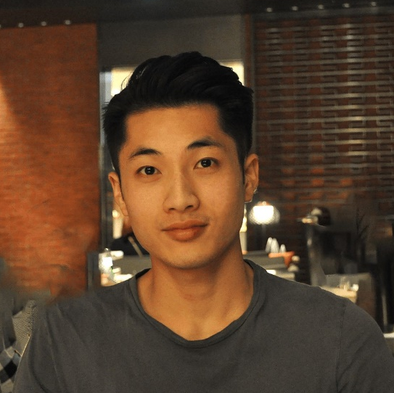
Hau Yin Jasper Mak
Address: Seoul Metropolitan City, Mapo-gu, Daeheung-dong 510
Nationality: British
Age: 26 (Date of Birth: 15/07/1992)
Email: mak.jhy@gmail.com
Mobile: +82 010-9808-1507
Marital Status: Single
Native English Speaker
Languages: British (Native), Cantonese (Fluent), Mandarin (Basic), French (Basic)

PROFILE
Graduated from the 8th and 10th best university in the World. Master’s degree graduate with English teaching experience at Chungdahm Institute as well as personal tutoring, teaching IT and acted as a teaching assistant in a special needs school. I am looking to gain more experience in teaching English as a foreign language in South Korea. I have lived in South Korea for 1.5 years.

EDUCATION AND CERTIFICATION
2016 TEFL 120-Hour TEFL Certificate (ODLQC, BAC, SQA Accredited) London, UK
- 100-hour online component – Grammar, teaching methodology, classroom management. I also learnt one-to-one teaching, teaching business English and teaching young learners.
- 20-hour classroom component – Planning, preparing and delivering TEFL lessons in an interactive classroom.

2014-2015 University College London MSc Infection & Immunity – Pass with Distinction (1st) London, UK

2011-2014 Imperial College London BSc & ARCS Biology – Grade 2:1 London, UK

2006-2011 Oundle School A Levels: 3A | GCSEs: 9A*, 2A Peterborough, UK

Skills gained: Communication, public speaking, organisation, analytical, attention to detail, leadership
- Under the Imperial College ‘Partner System’, I helped to guide 2 students with revision and university work.
- I gave over 20 presentations over the course of my BSc and MSc, including both individual and group presentations.

RELEVANT EXPERIENCE
2017-2018 Chungdahm Institute - Teacher Seoul, South Korea
Skills gained: Teaching, leadership, communication, organisation, creativity
- Planned and followed lessons that met lesson standards and objectives.
- Managing student homework, achievements and behaviour.
- Taught and managed varying levels of content and language abilities.
- Participated in professional development meetings.

2013-2016 Private Tutor London, UK
Skills gained: Teaching, communication, interpersonal, planning, creativity, organisation
- I planned and taught primary and secondary school students Biology in English as a part-time job over the course of both my university studies.
- I was requested for having a British English accent and occasionally taught the sciences to students.

2010 The Redway School – Teaching Assistant Milton Keynes, UK
Skills gained: Teaching, communication, interpersonal, creativity
- I assisted the teacher during lessons in a special needs school.
- I learnt new teaching methods including the use of sign language to ensure the students could fully understand the material and to guarantee the safety of the students.

2010 Oundle School – IT Teacher (Volunteer) Oundle, UK
Skills gained: Teaching, leadership, communication, interpersonal, creativity
- I taught members of the public with the use of computers and to teach anything particular to help solve their problems. I developed skills of effectively communicating technical information to lay people.

2010 Oundle School – Students Sports Club Supervisor (Volunteer) Oundle, UK
Skills gained: Organisation, creativity, leadership, managing children
- I supervised 10-12 year olds children in their weekly sports sessions.
- I designed activities and managed the children to ensure they are safe and learning.

ADDITIONAL EXPERIENCE
2016 Designing Hong Kong Hong Kong, China
Internship (Government, Preservation)
Skills gained: Interpersonal, communication, creativity, analytical, organisation
- Worked with students to design a community map identifying locals’ perspective on government plans.
- Collected data by speaking to members of public. Analysed oral and visual data to design a map allowing politicians and residents of Hong Kong to quickly understand the locals’ views.

2015 University College London London, UK
Laboratory Research Assistant
Skills gained: Teaching, leadership, analytical, organisation, flexibility, attention to detail, responsibility
- I led and trained an MSc student to operate in the lab safely and to analyse the data of her project.
- I designed, organised, executed and analysed experiments on patient samples in limited time. My contribution resulted in me being included in an abstract submitted to the British Society for Rheumatology annual meeting 2016.

ADDITIONAL SKILLS AND ACHIEVEMENTS

BSL (British Sign Language) Level 1 Qualification
I wanted to learn sign language to help others who require it to communicate and to make their lives easier.

Members of Imperial Football and Breakdancing Societies (2011-2014). Having good time management allowed me to take up two sports and I performed a dance routine at the 2013 UNICEF charity event.

IT SKILLS
MS Office, R Program, GraphPad Prism, FlowJo analysis software.

REFERENCES
Available Upon Request

