Jae Yi  7525 Petersburg St. Unit B, Anchorage, AK 99507  (p)907-727-1661• Email: iamjaee@gmail.com | 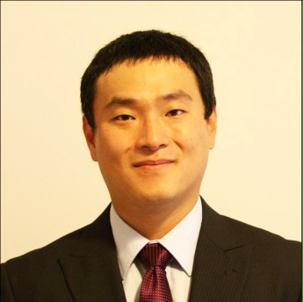

Objective
To obtain a teaching position in South Korea

Education
B.S in Technology  University of Alaska Anchorage, GPA: 3.2 | August 2008
A.A.S in Telecommunication, Electronics, and Computer Technology  University of Alaska Anchorage, GPA:3.2 | May 2005
Qualifications/Skills

- Proficient in Microsoft Office Products  - Proficient in Microsoft Project  - Excellent verbal and written communication  - Energetic, positive and self-motivated  - Basic Korean communication | - Three years of combine tutoring experience  - Strategic problem solving skills  - Experience teaching TOEFL curriculum  - Proficient utilizing technology

Work Experience
Science Teacher, Haven Christian International School 08/09 – 04/10
- Taught grades 7th – 12th and was the Homeroom Teacher for the Senior class
- Taught subjects in life science, space Science, speech, presentation, literature and writing
- Developed, coordinated and taught elective subjects in Guitar and Photography
- Was the acting college adviser. Guided graduating senior in achieving entrance in university such as University of Washington, Arizona State University, University of Bloomington, Oklahoma State University, and University of Michigan.

Middle School English Teacher, Avalon English Academy 11/08 – 07/ 09
- Taught Korean middle school students
- Creating lesson plans and daily curriculum specifically focusing on English and the IBT TOEFL exam.
- Check and correct essay and speech specifically targeting IBT TOEFL exam.
- Performed and managed verbal and written placement testing for students
- Conducted interviews for prospecting students

References
Available upon request; previous supervisors may be contacted

