Hedley James Benge
Upper Hutt
New Zealand
hedleybenge@gmail.com
Skype: hedley.benge10
Phone: 0226596873 (Country code is 64)

Education

- Accredited English Teacher (TESOL), Teach International, Auckland, New Zealand (2005)

- Korean TESL preparation course, NZ Institute of Education, Auckland, New Zealand (2011)

- Bachelor of Arts (Honours) – Classical Studies Major, Victoria University of Wellington, New Zealand

- Post-graduate Diploma in Information and Library Studies, Open Polytechnic of New Zealand

Teaching Experience

TESOL Training in New Zealand (2011 and 2005)

In 2011 I did a Korean TESL preparation course in Auckland which has involved some ESL teaching theory and applying that theory in a classroom practicum in the final week. A really interesting and exciting part of this course was the Korean language classes which put me in the role of language student and made me realise how hard learning another language can be so I can sympathise with my students when I get my own class.

In 2005 I did a 140 hour TESOL Certificate with Teach International which involved studying English grammar, teaching children and adults, Business English and IELTS. I have also tutored immigrants to New Zealand who wanted help with their English through the English Language Partners organisation in Lower Hutt. This experience involved preparing resources and lesson plans and assessing the learner. I had to build relationships with people from another country and I learned something about their cultures in the process. These experiences have helped me appreciate cultural differences and what it is like to work with someone in an ESL classroom to achieve a goal relevant to them.

Primary Teacher training in New Zealand (2008-2009)

In 2008-2009 I trained as a primary teacher and taught children in Years 3, 4 and 5 (ages 7-10). My training involved applying theory to classroom practice and I learned effective classroom behaviour management skills, how to plan for lessons and how to make my lessons interesting using interactive teaching to promote learning. My university transcript shows I have passed courses in teaching English (Merit passes), Mathematics, Science, The Arts (Visual Art, Drama, Music, and Dance), Technology and Physical Education / Health. English is a real strength of mine and the English courses I passed at University concentrated on teaching reading, writing and visual literacy.

English Language Instructor, CityKids School, YongIn, Korea (2007) / English Language Instructor, Daesin Oe Dae Language Institute, Busan, Korea (2006)

I was an English Instructor in Korea for 21 months where I taught preschool children, middle school children, teenagers and adults. I taught speaking, listening and writing using set texts. While I worked in Korea I started to develop skills in classroom management and I developed these skills further with my primary teacher training. In Korea I had to adapt to life in another country and communicate with speakers of another language. I think these experiences have given me more confidence in my own ability to succeed and I think they have made me a better teacher through having taught different age groups.

References

(Extracts from Rata Street School Teaching Experience report – June 2008)

‘You are a good, clear communicator and ensure all messages are clear and understood.’ (Liz Manins, Visiting Lecturer).

‘You have developed some effective management strategies and overall you are developing your practice well.’ (Liz Manins, Visiting Lecturer).

‘Hedley has made a big effort to build and maintain positive relationships with staff. He is responsible and trustworthy.’ (Clare Curry, Associate Teacher from Rata Street School, Naenae).

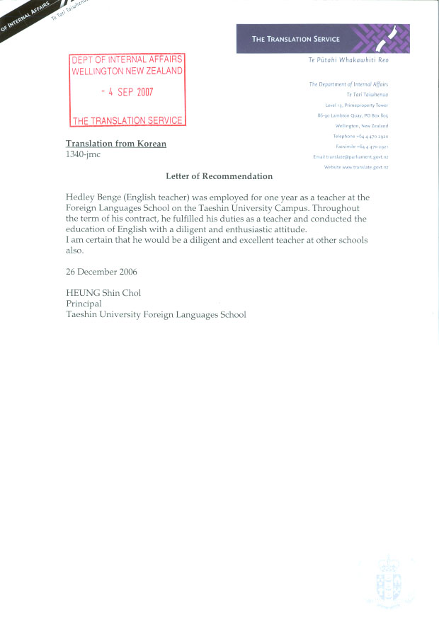

Rata Street School
Rata Street
Naenae
Lower Hutt
New Zealand

7 November 2008

Re: Reference for Hedley Benge

To Whom It May Concern,

Hedley worked in my classroom as a trainee teacher for four weeks in June this year. He proved himself to be an enthusiastic and determined individual with a willingness to learn.
Hedley worked hard to build relationships with the children in the class and the staff at the school, and to incorporate the various cultures within the school in his teaching.

He is reliable and well planned, and puts a great deal of effort into everything he does.

Yours sincerely,

Clare Curry
Teacher
Rata Street School

