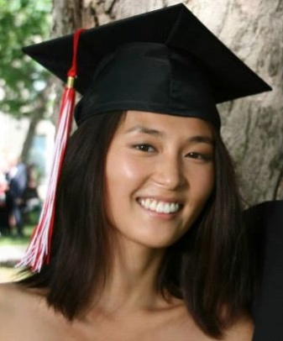

HyunJi Boo
Languages
English and Korean (Fluent)

Education
Bachelor of Science: Liberal Program in Anatomy & Cell Biology, Major Concentration in World Religions
McGill University, Montréal, Quebec

Work Experience
Therapeutic Music Instructor:
Wediko Children’s Services: 06/2012-08/2012
-Taught music to children, ages 6 to 18, with behavioral and emotional issues at a residential treatment summer program
-Developed children’s ability to build and maintain social relationships through support and counseling

Caregiver June 2009 – August 2009
Inter-Generations Geriatric Care Management, Inc., Arlington, MA, USA
-Scheduled appointments for the home visits by nurses and outside visits with doctors
-Managed the client's personal, medical and home needs during at home after surgery
-Provided 24 hour at-home care and subsequent shorter periods of care

Sales Assistant June 2008 – August 2009
EyeLook Optical, Lexington MA, USA
-Managed phone and internet supply orders
-Communicated directly with major lens and frame companies for updates on shipments
-Handled most administrative tasks including customers' phone calls, receipts, and payments

Volunteer Experience
English Teacher January 2012 – April 2012
Helambu Project, Nepal
-Taught beginners conversational English to nuns aged 6 to 35 at a Tibetan nunnery
-Evaluated students’ skills and planned courses independently

Volunteer February 2010 – April 2010
Dispensaire Diététique de Montréal, Montréal, PQ, Canada
-Assisted running the free day-care center while clients were in workshops
-Educated clients on the benefits of breastfeeding for the mother and child

Experiences / Interests
Lab Researcher May 2011 – December 2011
Joseph Dent Lab, Montréal, QC, Canada
-Researched the role and localization of acetylcholine gated chloride channels in the nematode
-Ran independent experiments and analyzed data

