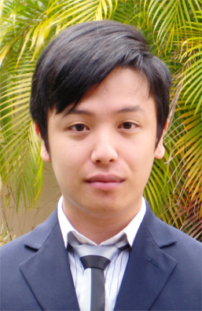
RESUME

Holly Calilung

PERSONAL INFORMATION

Name : Holly Andrade Calilung
D.O.B : 8 October, 1986
Address : 346-8 Seogyo-dong Mapo-gu Seoul
South Korea, 121-837
Mobile : 010 8477 3444
Email : quassiha@gmail.com

Interests : Studying Languages and Foreign Cultures, Singing, Painting, Travelling
Qualities : I'm a very sociable person and I get along very well with others. I'm polite and respectful towards my colleagues and superiors. I'm very enthusiastic and energetic about any work I'm given. I also try to be creative at problem solving. I'm happy to help out anyone who needs my assistance. I am a fast learner, and I enjoy challenges. I love experiencing new locations and meeting new people.
Career Objective : I want to work overseas and gain a broader understanding of different cultures and ways of living, especially in north-east Asia. I have a large interest in Japanese and Korean culture, so I have studied their languages and learnt about their cultures and want to be able to use what I know to interact with people and be part of a bigger community. I think working with school students is a very good way to begin working overseas. I also want to share with them the culture I come from and get them interested in the world. I intended to gain some experience teaching overseas before I return to University and complete an education and teaching degree.

EDUCATION
MacGregor State High School 1999-2003 MacGregor, QLD
Completed to a Grade 12 level, graduating 2003.

QANTM College 2004-2006 Brisbane CBD, QLD
Diploma of Screen, major in
- 2D Animation (3D Animation Minor)
Griffith University 2006-2009 (Graduating in December) Nathan, QLD
Bachelor of Arts, major in
- Japanese Language
- Japanese Culture
Akita International University (国際教養大学) Mar. 2008-Dec. 2008 Akita, JAPAN
Completed Study Abroad Exchange Programme at this institution.

WORK EXPERIENCE

BEST Fitness Sunnybank Hills, QLD
January 2009 – any time they need website update
Position: Graphic Designer for their website and advertisements
Duties:
- Create banners and logos for BEST Fitness website
- Design web page templates for future use

Kumon Learning Centre, Inc, Sunnybank Hills, QLD
March 2009 – June 2009
Position: Assistant Tutor
Duties:
- Responsible for elementary students
- Motivate students to do their homework and class work
- Record student work progression

Sogang University Language Program (SLP), Mapo-gu, South Korea
March 2010 – Present
Position: Kindergarten English Instructor
Duties:
- Teach English phonics to 6 and 7 year old students
- Prepare lesson plans for classes, write report cards for students' parents
- Assist in social development of my students

OFFICE SKILLS
- Microsoft Office (Word, Powerpoint, Excel)
- Adobe Photoshop CS3, Corel Painter
- Adobe Flash
- Basic web design skills

REFERENCES
Dr. Leigh Kirwan – (Griffith University – Japanese Language Lecturer)
- (07) 555 28612
- l.kirwan@griffith.edu.au
Ms. Jin – (Mapo SLP – my teacher leader)
  - 010-5068-6488

Yosuke Hashimoto – (Akita International University – Japanese Language Lecturer)
– yosuke19791005@hotmail.com
– yosuke@aiu.ac.jp

